November 2017 Newsletter
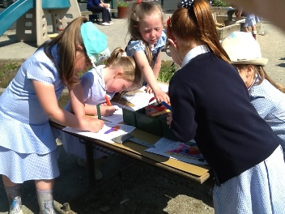
Reception/P1 Pupils
Do you know of any pupils in the local area who are perhaps old enough for Reception Class (children who have turned 4 since 2nd July 2017 or due to turn 4 soon), or any pupils currently at nursery or Playgroup and due to begin school next September?

The time for pupils to apply for places in Primary School is approaching soon. We would appeal to you to please let any parents know about our fantastic school and/or ask them to get in touch to arrange a visit and meet the staff and pupils. Or – let us know about any pupils who may be considering St Eugene’s for their child.

Open Day
Our Open Day for parents of prospective pupils will take place on Tuesday 28th November from 9.15 – 3.15.
Parents of children of any age for Primary School are very welcome along, but most especially parents of those children who are already 4 years of age or who will be turning 4 any time before 2nd July 2018 are invited to visit the school on this day. The day will allow parents and children the opportunity to see our school in operation, meet the staff and pupils and see what St Eugene’s PS Victoria Bridge has to offer.

Teacher of the Year Awards
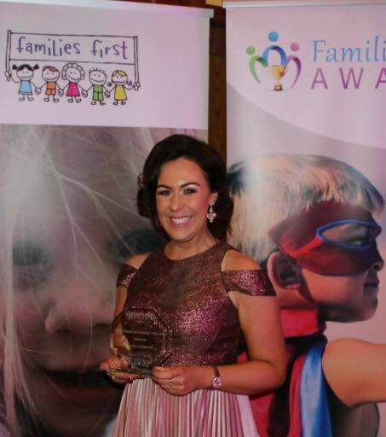
Huge congratulations to Miss Gormley who last month was awarded the Families First ‘Best Primary School Teacher of the Year’ award at a special prize giving event in Donegal Town on Saturday 7th October.
Everyone connected with St Eugene’s was overjoyed to see Miss Gormley’s hard work being recognised through her nomination. For that nomination to lead to Miss Gormley being chosen as the recipient of the award is such fantastic news for Miss Gormley, her family and friends and of course, the entire community of St Eugene’s. Well Done Miss Gormley – We are all so proud of you.
Thank You too, Mrs Debbie Gallagher who was responsible for the original nomination…how right Mrs Gallagher has proven to be!

Diary Dates
- Monday 13th – Friday 17th November – Anti Bullying Week
- Wednesday 15th November – Whole School Flu Vaccinations
- Friday 17th – NSPCC Workshops & ‘Odd Sock Day’
- Wednesday 22nd November – Final Library Van visit of the term
- Tuesday 28th November – ‘Open Day’ for prospective new pupils and parents
- Wednesday 22nd November – Tuesday 28th November –Scholastic Book Fair

School Promotion
We will shortly be embarking on a promotional drive using posters and flyers. Could any parent who would be willing to ‘leaflet drop’ in their area or any parent who is aware of a business or shared community for displaying a poster ring the office and give their name to Mrs Gallagher.

Value of The Month – October
Respect – Please discuss this value at home with your child(ren). Adults will be on the lookout for children displaying this value throughout the month.

Parent Teacher Meetings
Thank You for attending these meetings during the week before Mid –Term Break. We hope that the meetings were useful and helped you as parents to understand how your child is doing at school. Remember – teachers are willing to meet throughout the year should any issues arise. If you are concerned about your child at all, or have anything that you need to share with your child’s teacher, please arrange an appointment through the office.

Welcome
Welcome to Miss Marie Breslin who will be joining the staff team for the remainder of the year. Miss Breslin is a HND student from North West College and will be providing assistance in Miss Gormley’s class and Mrs Connolly’s class on a Monday and Thursday each week.

Sacraments
Our new Chaplain, Fr Canning has visited the school on a number of occasions since his arrival in the Parish. We are delighted that he has also already informed us of the dates for the sacraments of Confirmation (Saturday 3rd March 2018) and First Holy Communion (Saturday 12th May).

Anti-Bullying Week
Anti-Bullying Week takes place from Monday 13th – Friday 17th November. In each of our classrooms, pupils will have the opportunity to engage in activities on this subject. The NSPCC will also provide presentations and workshops during this week, particularly on the theme of ‘Speak Out, Stay Safe’ and on Friday, the school will have an ‘Odd Sock Day’. Pupils are asked to come to school in their brightest odd socks and bring a minimum donation of £1. All monies raised will go to the NSPCC to assist them in delivering the programme as the NSPCC do not charge a fee.
During this week we will also send out our Anti Bullying Policy to you our parents for consultation. Please complete and return the slip attached to the Policy, on or before Friday 1st December 2017.

NSPCC – Internet Safety Workshop
Earlier in the year we sent out a letter with the offer of a free NSPCC led ‘Internet Safety Workshop’ for parents. Unfortunately, the uptake has not been at the required level to run the workshop. If any parent might reconsider attending, please let the office know and we will investigate the option again.

Breakfast Club
Our Breakfast Club is proving to be very helpful for a number of parents who are dropping their children off earlier. The cost of £1 is extremely low for supervision and Breakfast – but we still need this venture to be better supported.
If you need to drop your child off earlier than 9.00 but they do not want breakfast, they can still be supervised by Mrs Preston – please remember to send in the £1 though!

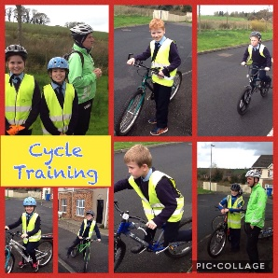
SUSTRANS Active Travel Programme – Cycle Training
Congratulations to our P6 and P7 cyclists who participated in the Sustrans On-Road Cycle Training. 16 pupils took part and we are delighted to report that all 16 pupils passed both Levels 1 and 2. What a great achievement! The two instructors were very complimentary about the behaviour, attitude and skill of the children and the positive welcome that they received in our school.

Annual Report 2016/17
The Annual Report of the Board of Governors will be available in the office from Monday 20th November. Please contact Mrs Gallagher if you would like to avail of a copy.

Gaelic Coaching
P6 & 7 pupils will be enjoying Gaelic Football Coaching with Conor Gormley on a Wednesday from 11.00 – 12.00. PE Gear is necessary for this activity, especially a suitable waterproof jacket or hoodie as the children will be outdoors when it is dry and not too cold! During the next few weeks, when pupils will also be attending swimming, P6 & 7 pupils can come to school in the morning in their PE Gear and can then change into their uniform after Gaelic is over on a Wednesday.

Prayer of the Month – November
Prayer for the Faithful Departed

Eternal rest grant onto them O Lord,
and let perpetual light shine upon them.
May their souls, and the souls of all the faithful departed,
Through the mercy of God,
Rest in peace
Amen.

Healthy Break
In St Eugene’s we promote a healthy lifestyle and diet. We encourage all pupils to bring a healthy snack to school for mid-morning break. Please refer to the list of healthy options available on the website or through Twitter (@StEugene58) and Facebook
Meet the Principal Coffee Morning
Thank You to the parents who were able to attend this event in October. We had a very open and worthwhile discussion about many aspects of our school and we certainly appreciate the parental feedback and ideas that came out of the event.

Library Van
The Library Van will visit this month again but will not visit again after Wednesday 22nd November, until January 10th 2018!
Roots of Empathy
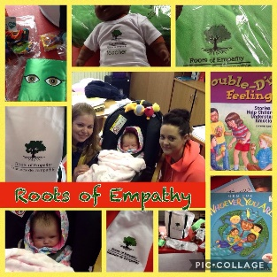
Mrs Connolly’s P3-5 class have begun participating in this exciting programme led by Mrs O’Kane (our R.O.E expert) and with the important involvement of parent Donna Marie and of course baby Kyla. The class had their first session on Tuesday afternoon and are looking forward to exploring empathy, feelings and emotions with the help of the adults involved and also learning about the development of a baby. We are excited that we have the opportunity to participate in ‘Roots of Empathy’. If you have any questions or would like more information, let us know.
Christmas Show/Nativity
Advanced notice of this year’s Christmas Shows in the school. These will take place on the morning (10.00) and evening (7.00) of Tuesday 12th December. We look forward to joining with you our parents to celebrate Christmas with our pupils and enjoy their talents on stage. Our Christmas Draw will take place at the evening performance. This is our main fundraiser for Term 1 so we would appeal for parents to support it as well as possible by selling tickets and/or donating a prize. More details to follow later in the month.

‘Oh Yes It Is!!’
Our annual trip to the Christmas Panto (Jack & The Beanstalk) will take place on Tuesday 19th December. You should have by now received a note about this – please try to pay the £10 per child as soon as possible. This is such a wonderful occasion for the entire school to attend – the children are so excited already!

Anyone for Golf?
‘GolfScool’ will provide golf lessons (in January) for pupils from P1-3 and P4-7 if we have enough interested pupils. Lessons will last for 1 hour (2.15-3.15 & 3.15-4.15) at a cost of £30 for a 6 week block of lessons. No previous experience of golf is necessary and ‘GolfScool’ provide all the equipment necessary. If you are interested in your child attending, send in a note to that effect or ring the office…perhaps we will have the next Rory McIlroy or Leona Maguire on your hands!

FLU Vaccination
Next Wednesday the School Nurse and team will visit our school to administer the Flu Vaccination to our pupils in the form of a nasal spray. We hope that this will help our pupils maintain good health over the winter months.

Book Fair!!!!
Scholastic Book Fair will be coming to our school from Wednesday 22nd November until Tuesday 28th November. The Book Fair always provides a wonderful selection of books for pupils at keen prices and might interest parents especially with Christmas approaching. The Book Fair is a wonderful means for our school to promote reading and all of its benefits. Pupils will all have a chance to visit the Book Fair (set up in the hall) and browse before purchasing items. Pupils can purchase on any day. The Fair will also be open to parents or anyone in the wider school community on Friday 24th (2.00-3.30) and again on Tuesday 28th (2.00-3.30) for purchasing. Remember that the school will benefit from a % of the intake which we can then use to purchase reading materials for our pupils so any purchase made is supporting our school and pupils.

