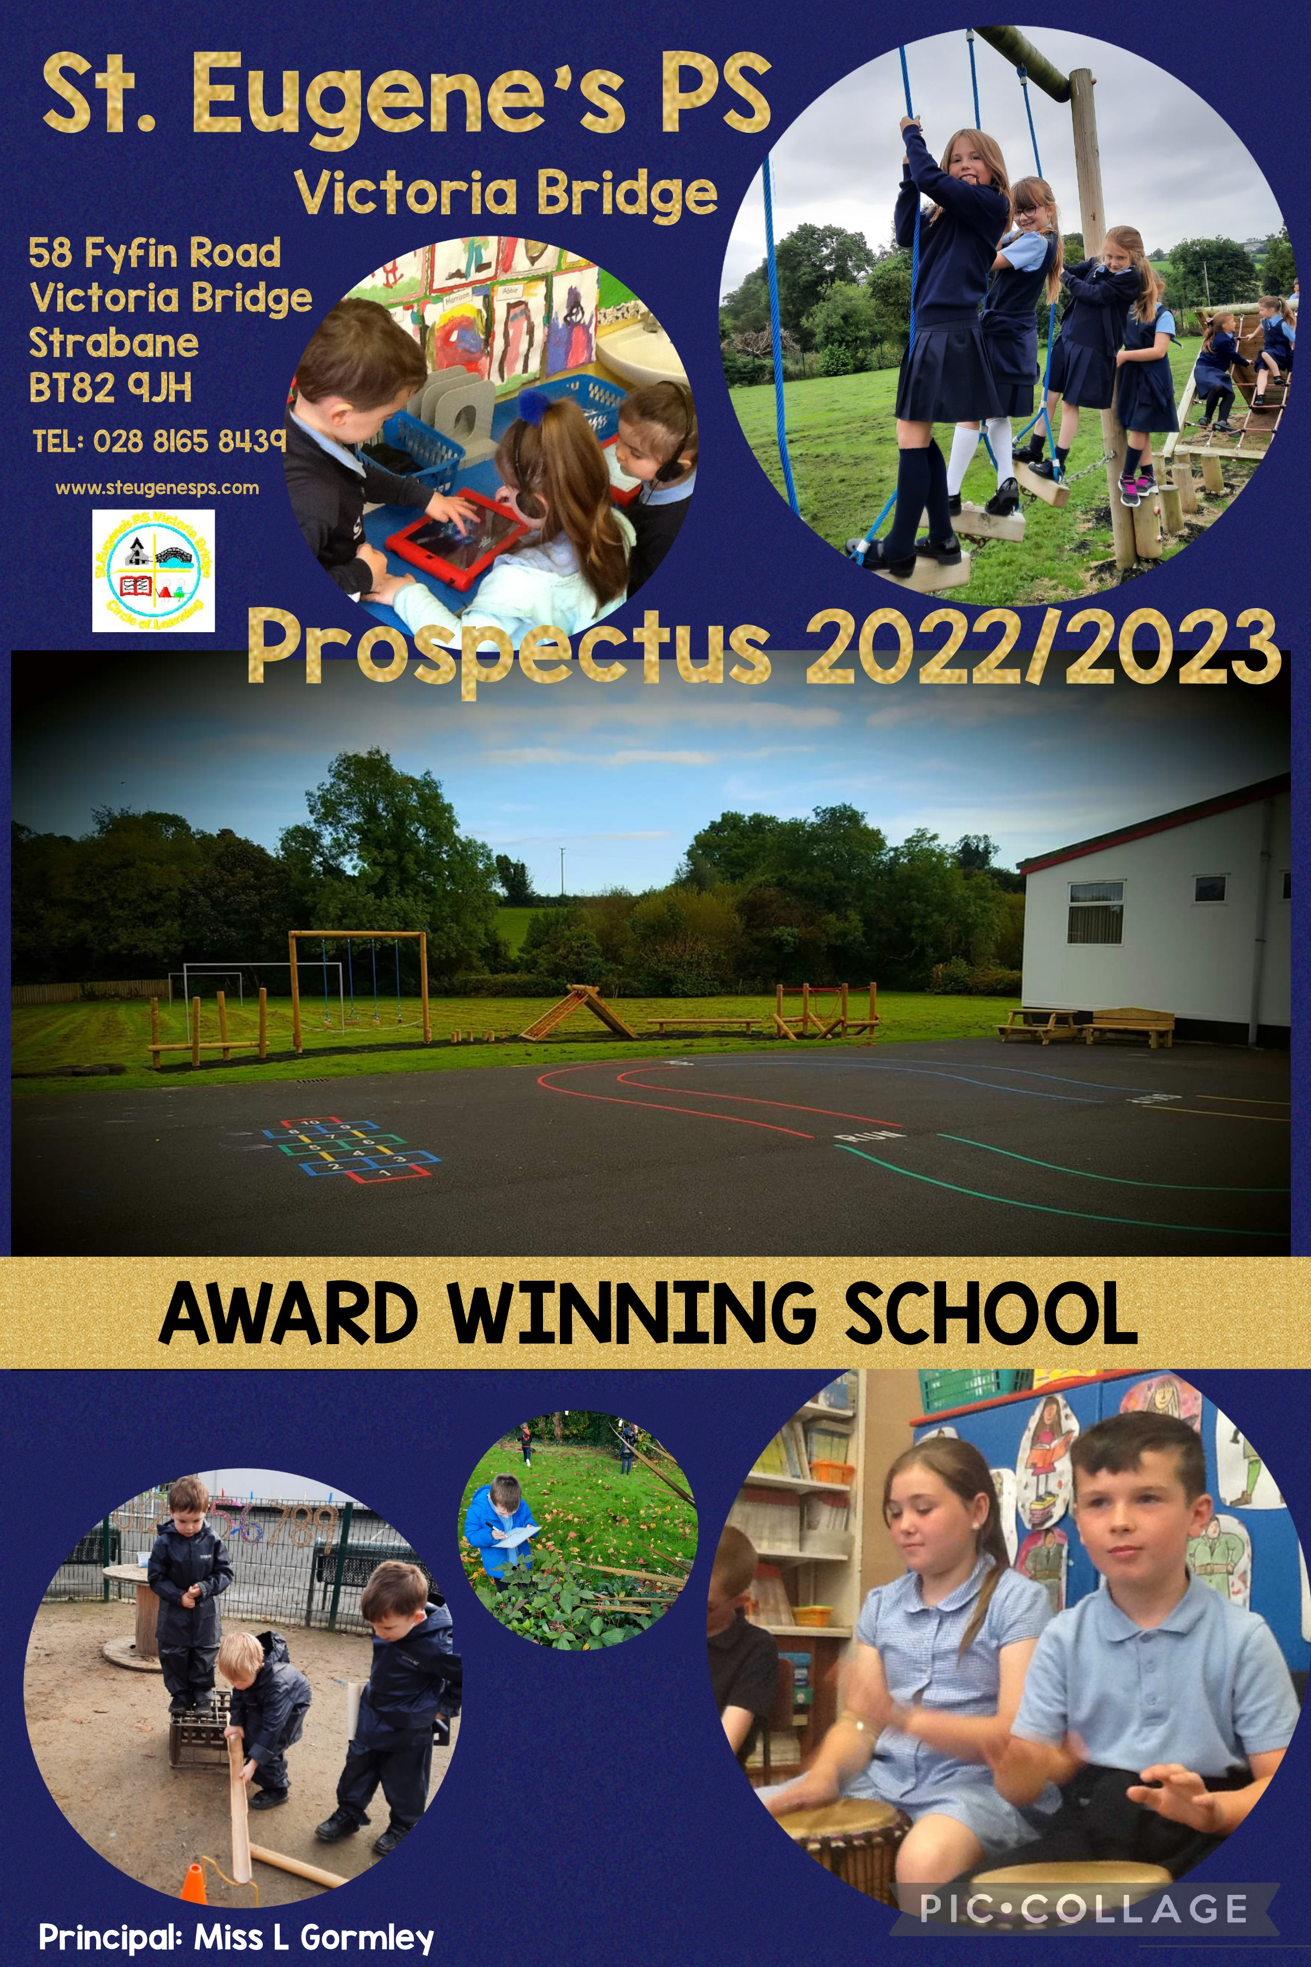


On behalf of the pupils, staff, parents and Governors of St Eugene’s Primary School, I extend a warm welcome to you and your child.
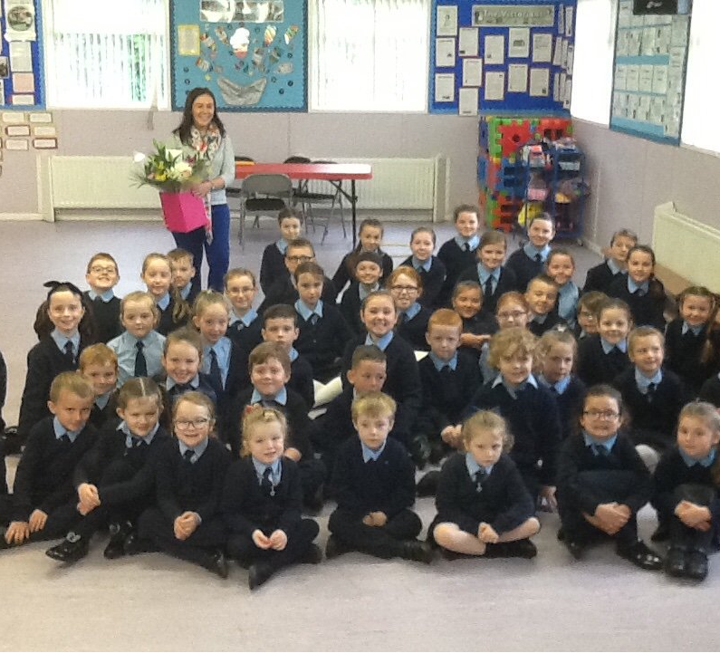
Here in St Eugene’s we have a long tradition of serving the community of Victoria Bridge and beyond by providing high quality education in a peaceful and tranquil environment loved by pupils and staff alike.

As a small school, the confidence,
self-esteem, happiness and personal development of our pupils is central to everything that we do and we take great pride in our school and in everything that we achieve.

We are winners of the Families First ‘Best Rural Primary School’ award 2018 and ‘Best School in the Community 2018’

For our pupils, St Eugene’s Primary School is very much a home from home.

An essential ingredient of our school ethos is working together to achieve – children, parents, staff, governors, parish and the wider community and this is reflected in our school motto…’Circle of Learning’.

We hope that our prospectus will give you a feel for the child-centred provision that is available here in St Eugene’s, from the early years of our Pre-School/Reception provision, up to the senior years of Primary 7. Should you require any further information about the curriculum we provide or wish to see the school and experience first-hand the facilities on offer, please do not hesitate to contact us and arrange a visit.

Laura Gormley

Principal
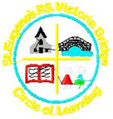

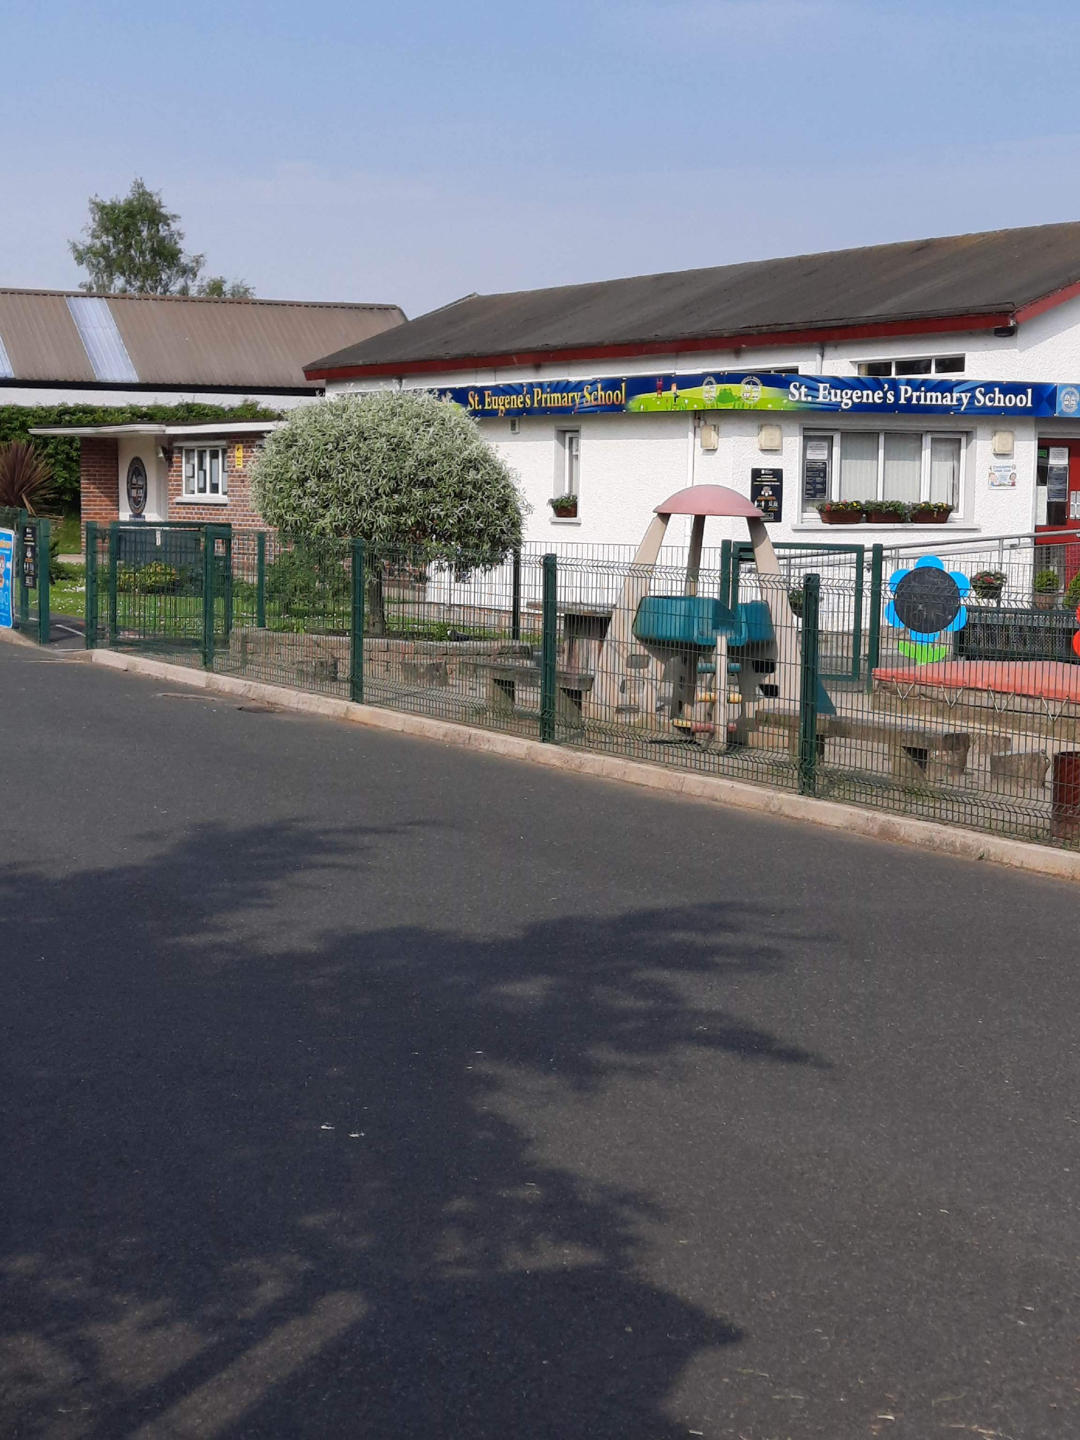
GENERAL INFORMATION

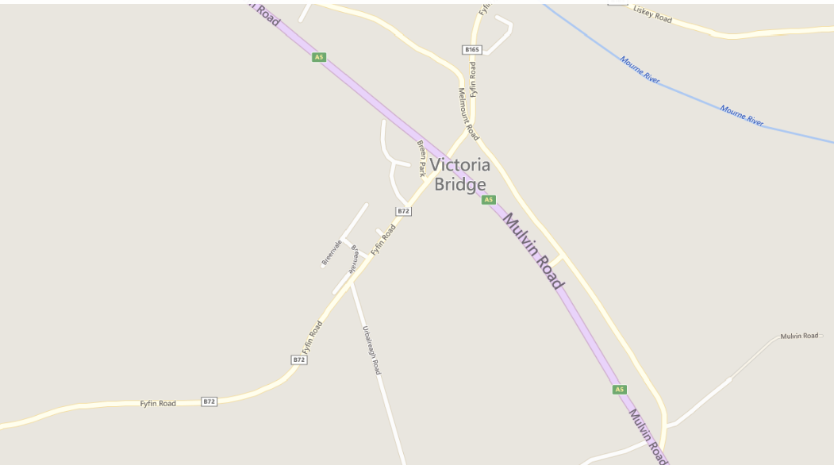
St. Eugene's Primary School is a Voluntary Maintained Primary School, owned by the Trustees representing the Parish of Sion Mills and is maintained by the Education Authority. It admits boys and girls aged from four to eleven. The school was founded in 1960. In the heart of the village of Victoria Bridge, our school is set in a peaceful and tranquil environment loved by pupils and staff alike. Our pupils travel from many surrounding areas to avail of our excellent provision. Saint Eugene’s PS is a 5-minute drive from Strabane via the Liskey Road, 2 minutes from Sion Mills and 10 minutes from Castlederg. An ideal location for parents commuting to Omagh or Derry with the added benefit of the Breakfast Club available from 8:15am daily.

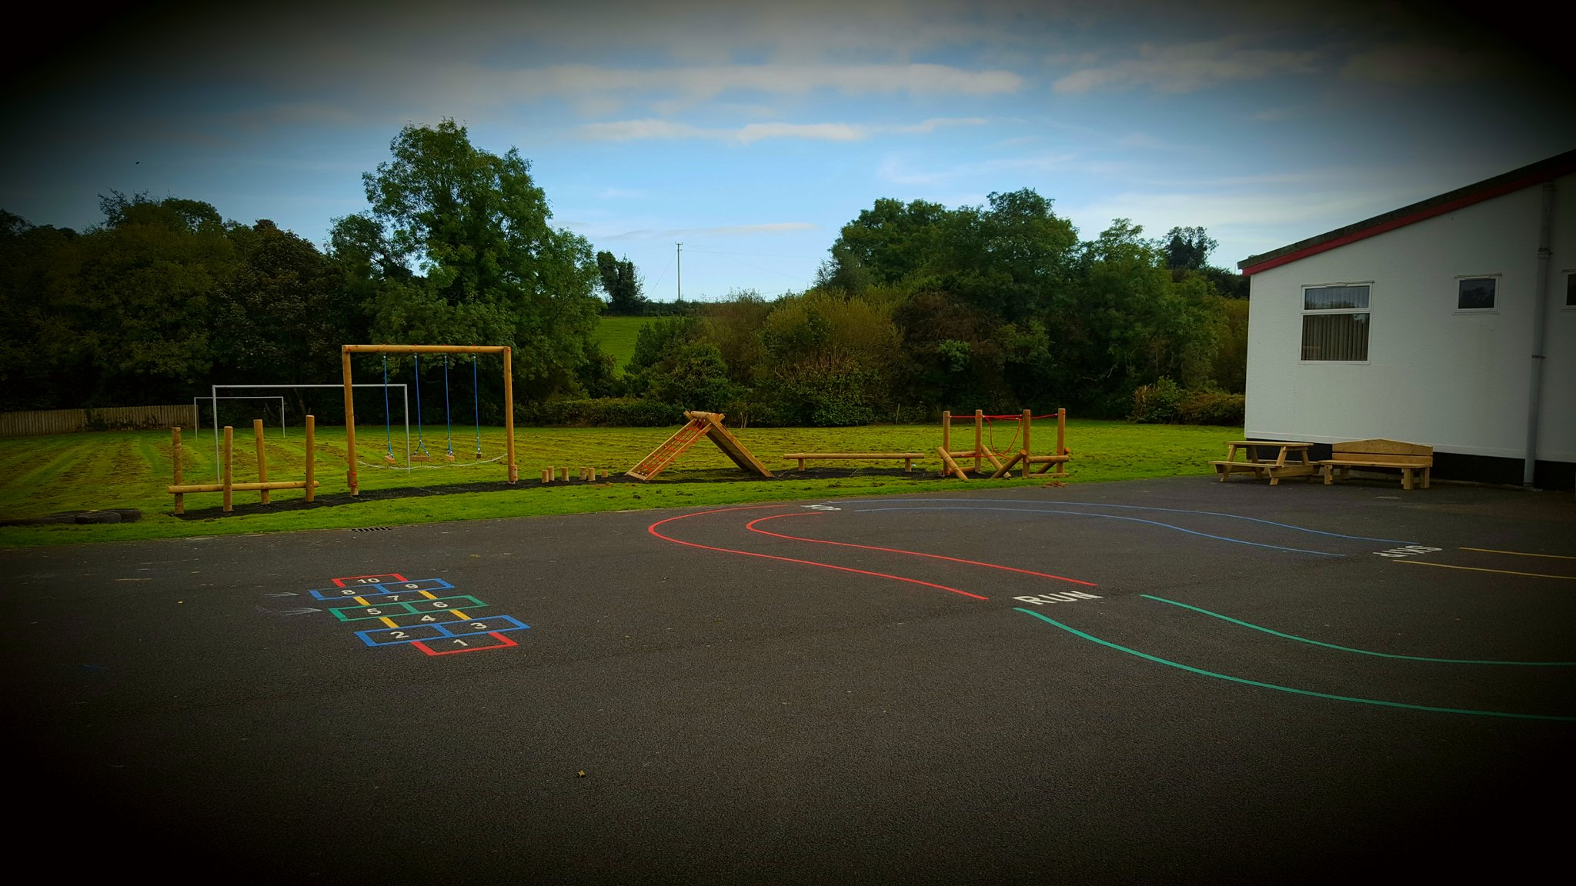
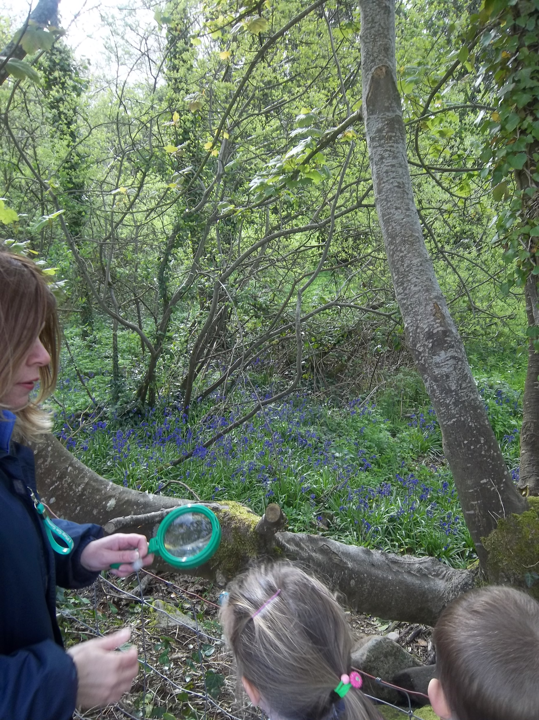
In addition to the main school building, St Eugene’s boasts a fantastic hall, outdoor play area, football pitch, climbing frame and trim trail, two well equipped playgrounds and our own little nature reserve.

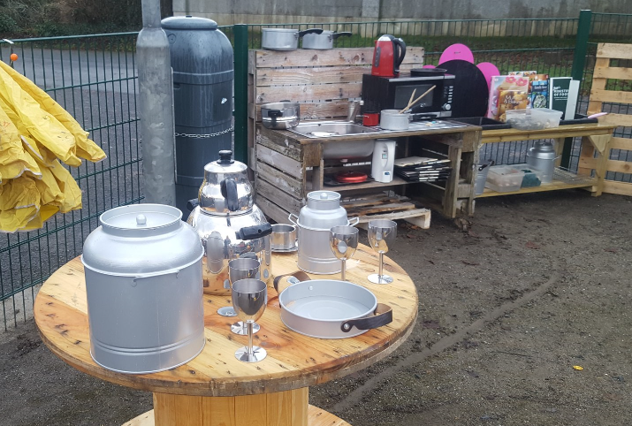

St Eugene's offer an all-inclusive learning community dedicated to nurturing the intellectual, physical, spiritual, moral, social and emotional development of each individual child. Staff aim to provide a broad and balanced curriculum and are deeply committed to providing the highest standard of teaching and learning. The school encourages all to realise their full potential in a caring and engaging Catholic environment. Our staff aim to provide a broad and balanced curriculum and are deeply committed to providing the highest standard of teaching and learning.
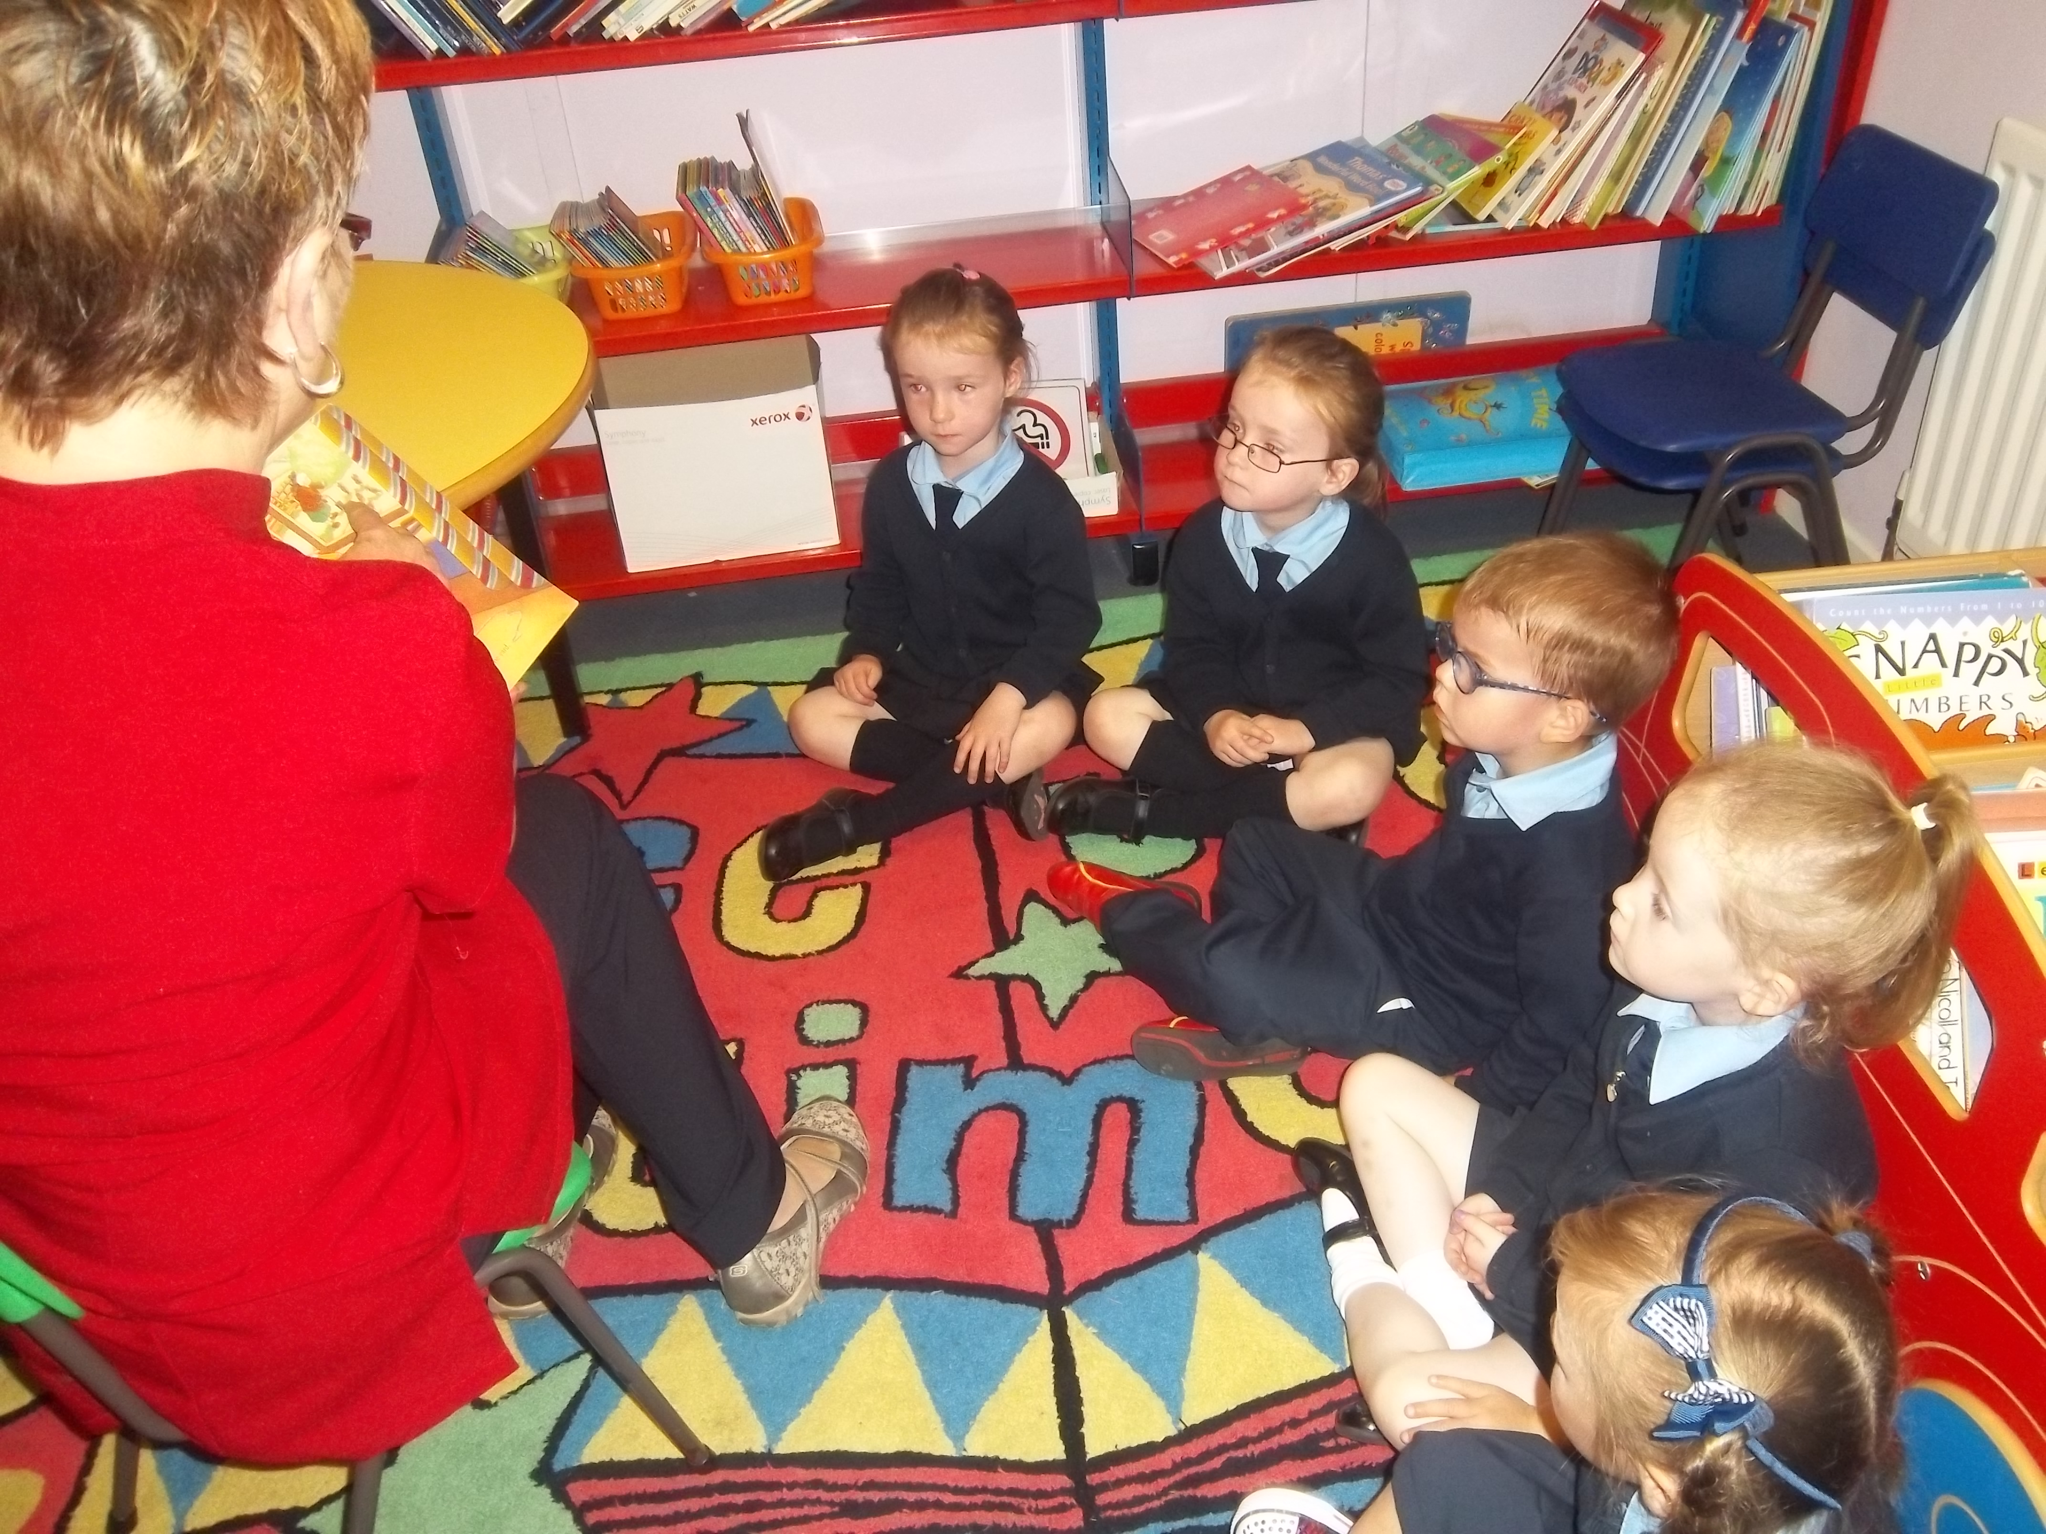
The Northern Ireland Curriculum is delivered through three key stages at primary level:
- The Foundation Stage: Years 1 and 2
- Key Stage 1: Years 3 and 4
- Key Stage 2: Years 5, 6 and 7
The areas of learning include:
- Language and Literacy
- Mathematics and Numeracy
- The World Around Us
- The Arts
- Physical Development& Movement
- Personal Development & Mutual Understanding
- Religious Education
For more information visit: CCEA Curriculum pages or follow the links from our website. Our Reception class are provided with a range of opportunities and experiences in which learning is promoted through play. These children follow the Northern Ireland Pre-School Curricular Guidance. For more information visit: CCEA: Pre-School Guidance follow the links from our website.
TEACHING STAFF
Principal Miss. L Gormley/Mrs. C McDermott
(Reception & Years 1 & 2) Assisted by Mrs. L Bride & Miss. E O’Brien

Teacher Mrs. D Connolly
(Years 3, 4 & 5) Assisted by Mrs. S Preston & Miss. S O’Kane

Teacher Mr. P Donnelly
(Years 6 & 7)
The aims of our school are for each pupil to learn to:

- Read fluently and with understanding and pleasure.

- Talk clearly, confidently and grammatically.

- Write sensibly, fluently, grammatically and imaginatively.

- Listen attentively with understanding.

- Acquire a good sound knowledge of the basic number facts.

- Acquire computational skills and to be able to apply them with speed.

- Apply himself/herself to mathematical tasks with confidence and skill.

- Become aware of the nature of science and its relevance in their immediate environment.

- Acquire knowledge and understanding of the World Around Us through Science, History and Geography based topics.

- Develop agility, confidence in and through physical activity and the ability to express feeling through movement.

- Develop awareness of self and sensitivity to others, acquire a set of moral values and the confidence to make and hold moral judgements, and develop habits of self-discipline and acceptable behavior.

- Develop the capacity to become a contributing member of the community.

Through these aims it is hoped that pupils will:

- develop a sense of self-respect, the capacity to live as independent, self-motivated individuals and the ability to function as contributing members of co-operative groups.

- develop lively enquiring minds, the ability to question and argue rationally and to apply themselves to tasks and to develop physical skills.

- develop respect for religious and moral values and tolerance of other races, religions and ways of life.

- develop their abilities in all curricular areas and fulfil their personal potential to use these abilities.

- develop their learning in all spheres and to help them develop a love of learning.

- respect and understand the world they live in and the interdependence of individuals, groups and nations.

SCHOOL HOURS
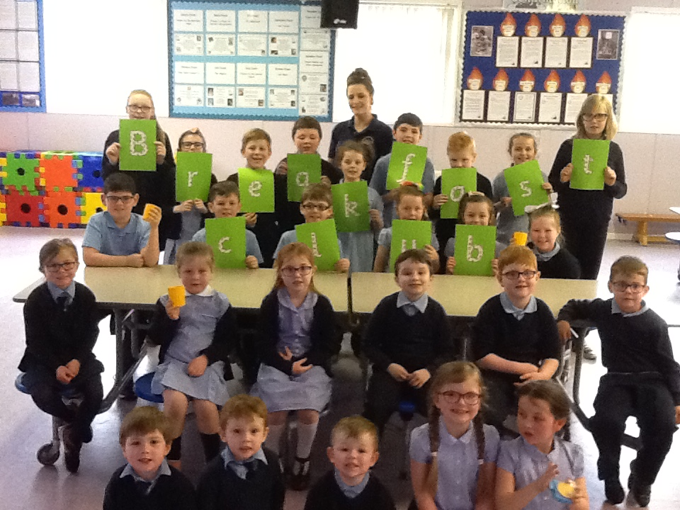
The school day begins at 9.15 am. Pupils can arrive from 9.00am onwards, however, we do offer a Breakfast Club from 8:15am for any pupils who need to be dropped off before 9.00am. The cost of the Breakfast Club is currently just £1.
- All the children have a supervised playtime for 15 minutes from 10.45 – 11.00am.
- Lunch break is from 12.30 to 1.15 pm.
- Reception children will attend school until lunch- time only (i.e.) 12.30pm.
- Primary 1 & 2 finish their school day at 2.15 pm.
After school supervision and games are available for eligible child in P1 and P2 children until 3.15pm.
- Primary 3 - 7 pupils finish at 3.15 pm each day although occasionally children may not leave until a few minutes later if there are clearing tasks to be completed.
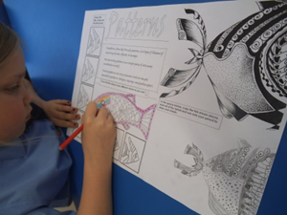
WE ARE PROUD TO BE ONE OF THE ONLY SCHOOLS IN THE AREA ABLE TO OFFER A FULL RANGE OF AFTER SCHOOL CLUBS FROM 3:15 TO 4:15 MONDAY TO FRIDAY.
At St Eugene’s PS we continually review and evaluate our after-school and extra-curricular provision. Here are some of the activities enjoyed by our pupils:
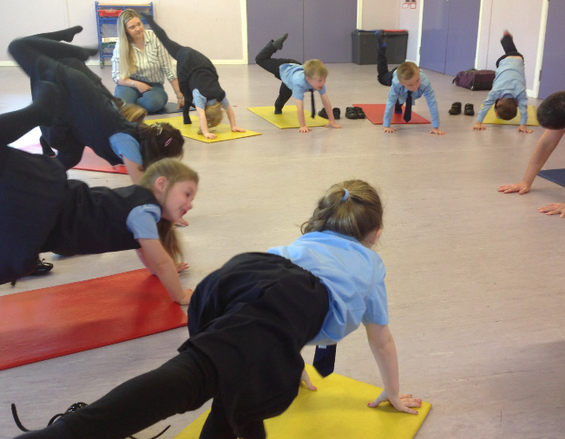
- Art Club
- Film Club
- Games Club
- Fitness Club
- ICT Club
- Let’s Play Club
- Mindfulness Club
- Swimming
- Gaelic Football
- Tin Whistle
- Yoga

ATTENDANCE
All children should attend school for the 190 days, which the law requires, unless they are ill. Due to legislation drawn up by the Education Welfare Department it is now absolutely necessary for parents to inform the school either in writing or telephone of the reason for the child’s absence from school. Children’s attendance is now completed on computer. Long absences or erratic attendances must be brought to the attention of the Education Authority for investigation.

PUPIL WELFARE
All staff work closely together in consultation with parents to ensure the welfare of children in the school. Parents are urged to discuss any matters of concern with staff whenever they feel this is advisable. Parents are strongly advised to discuss such matters with the class teacher in the first instance. Often potential problems can be avoided if they are dealt with quickly. The Principal will be pleased to see parents to discuss any matters of concern they may have although it would be appropriate to make an appointment as the Principal teaches full time and a lengthy discussion may be needed.

CHILD PROTECTION
The school has drawn up a Child Protection Policy in accordance with Department Guidelines. All members of staff have been made aware of the Policy and the fact that any matters of concern should be brought to the attention of the Designated teacher, Miss Gormley, in Miss Gormley’s absence concerns should be brought the attention of the Deputy-Designated teacher Mrs Connolly.

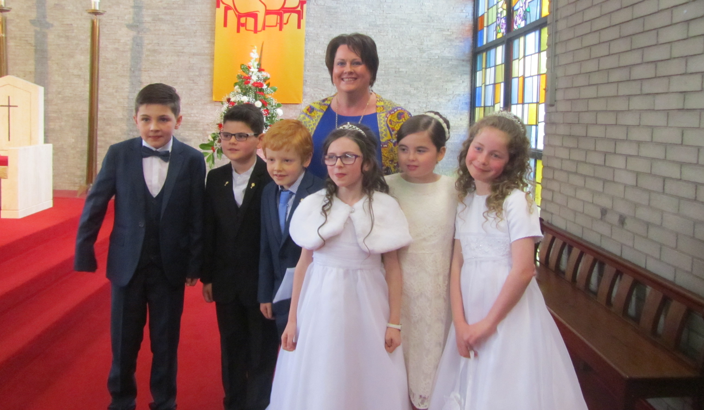
RELIGIOUS EDUCATION
Religion is an important element of the school's life. The school sees itself as an extension of the home and as such it seeks to support, extend and clarify the Catholic faith which children live at home and in church. Every effort is made to foster a Catholic ethos within the school with the active encouragement of class prayer and school assemblies. There is a strong programme of Religious Education in the school which includes following the church calendar and bible stories. Fr. Thomas Canning, makes frequent visits to the classrooms and talks with the children about their sacramental preparation.

SPECIAL EDUCATIONAL PROVISION
Care is taken at all times to match the curricular provision for all children to their particular stage of development and to take account of any particular difficulties or special talents which they show. Where provision beyond what can be given by the class teacher is required, the Code of Practice for Special Education is used so children requiring specialist services may benefit from them at the earliest opportunity. This should enable the child to develop strategies that will help overcome or lessen the difficulties being experienced.

ADMISSION ARRANGEMENTS 2022/2023
The current policy is to admit into the P1 class on the first day of the autumn term those children who have reached the compulsory school age, i.e. those children whose 4th birthday falls on or before 1st July 2022. Applications to have children enrolled at other times during the year will also be given consideration. The same criteria will be used on deciding in admission of such pupils.

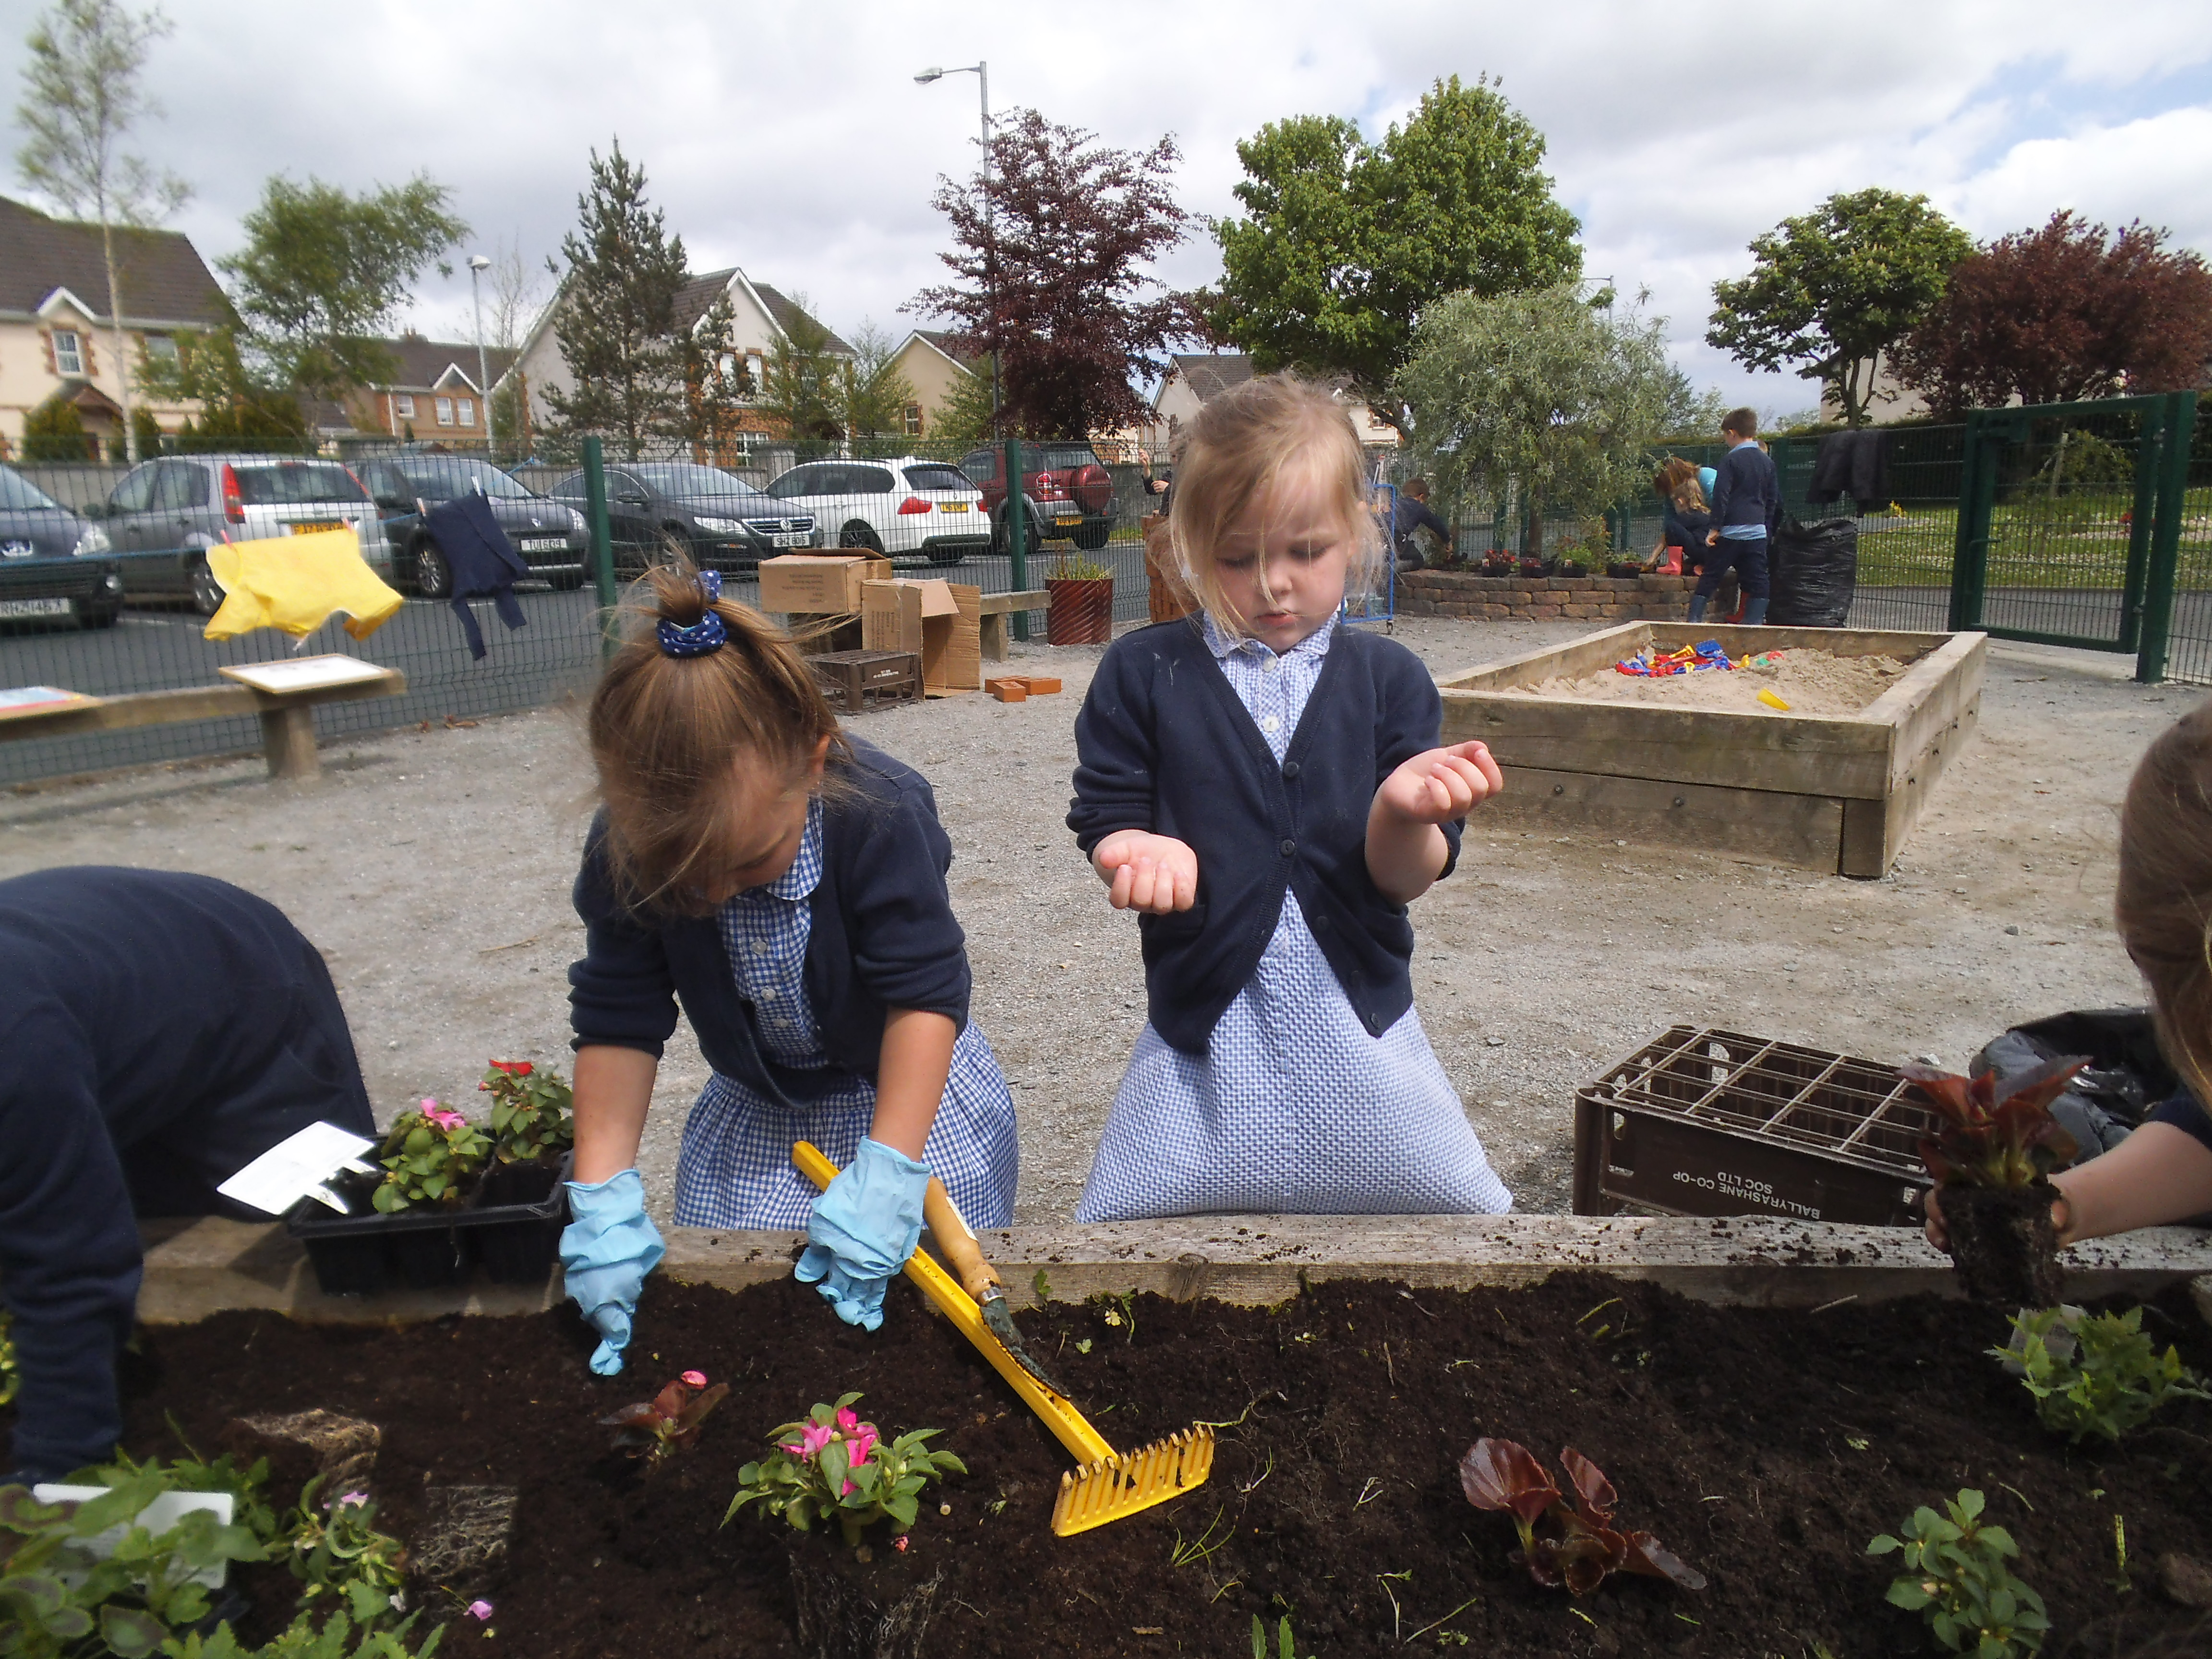
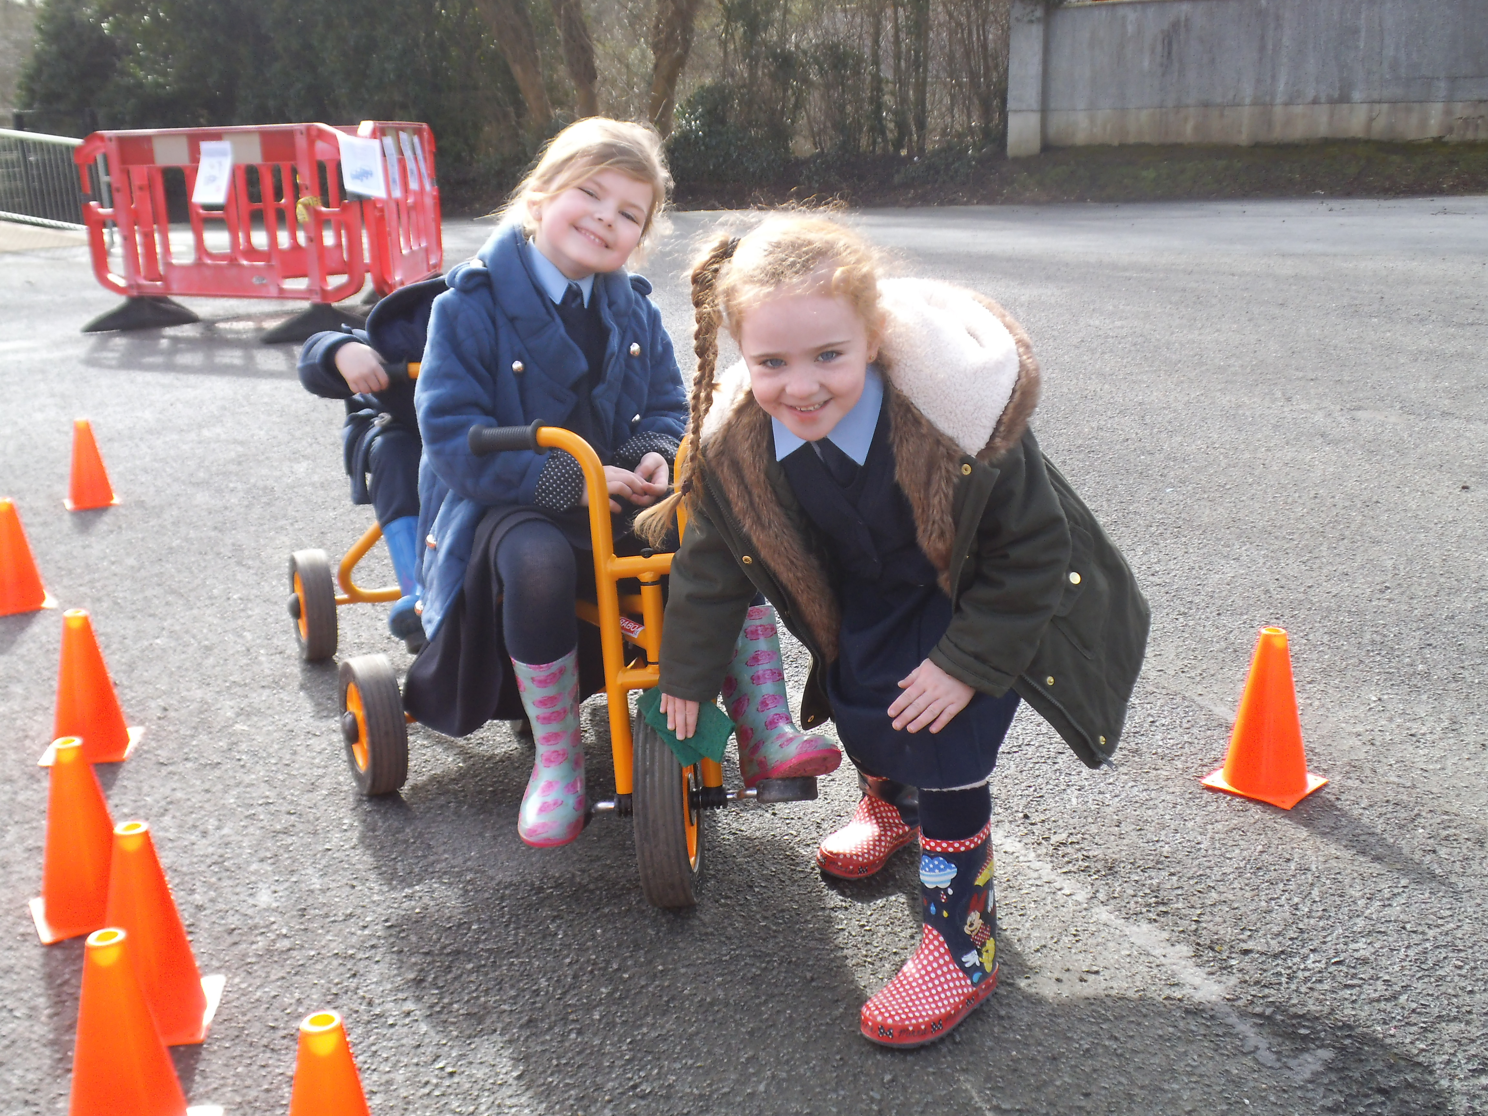
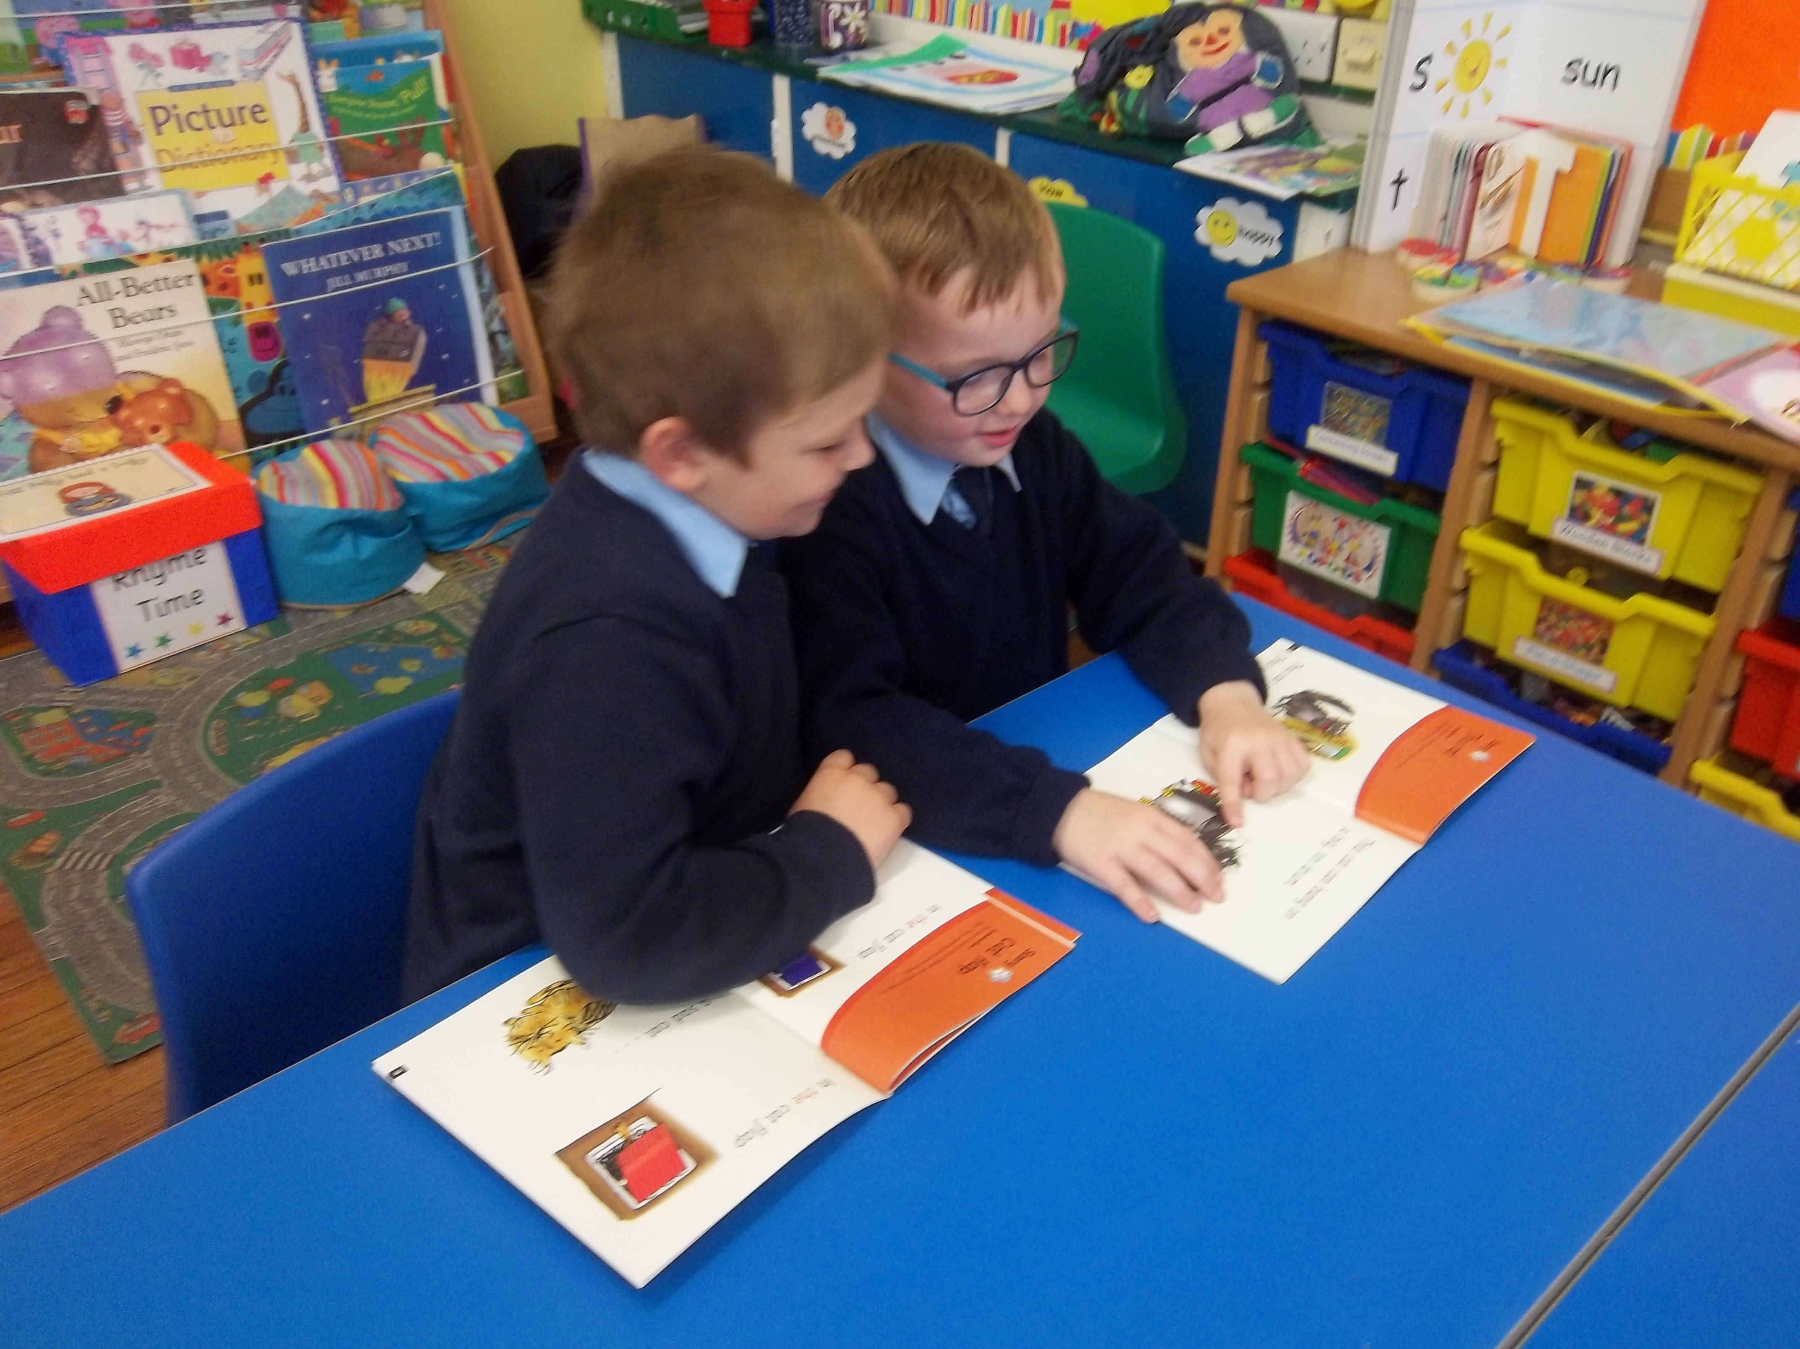

ADMISSIONS CRITERIA - Year 1

The Board of Governors will apply the following criteria in the event of there being more applicants than places available, in the order set down. Priority will be given at all times to pupils regarded by the Board of Governors, on the basis of supporting evidence by parents/guardians and/or statutory agencies, as having special circumstances (medical, social, security factors). Priority shall be given to children resident in Northern Ireland.

- Children of compulsory school age whose brothers/sisters, half-brothers/half-sisters are presently enrolled in the school.
- Children of compulsory school age who normally reside in the Parishes of Camus, Ardstraw East and Sion Mills.
- Children of compulsory school age from other areas.

In the event of over-subscription in any one of the criteria, taken in order, pupils will be selected on the basis of proximity of parents'/guardians' home to the school as measured by the shortest walking route by public thoroughfare.
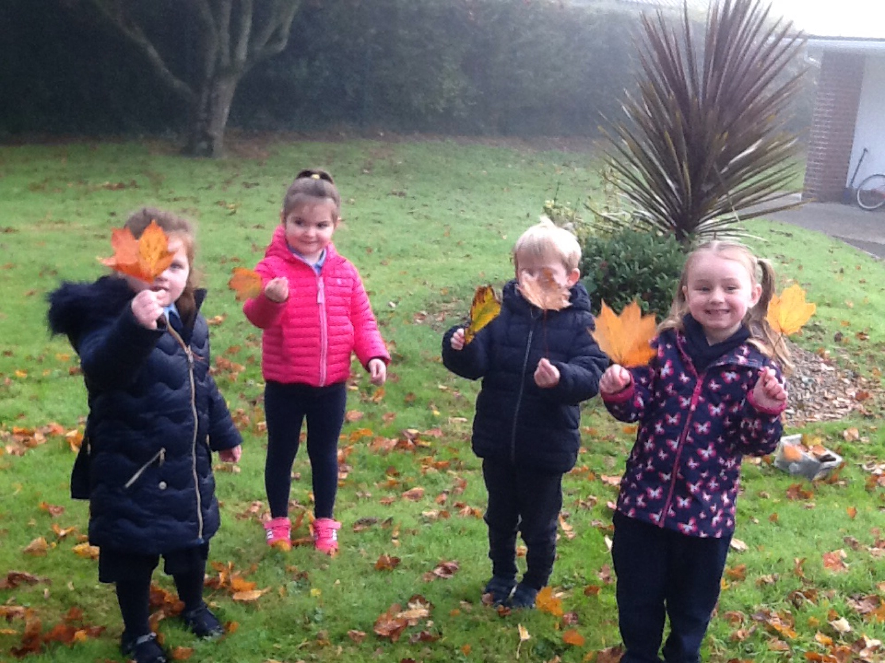

ADMISSIONS FOR PUPILS BELOW COMPULSORY SCHOOL AGE

Children age 4, but who have not attained the lower limit of compulsory school age (who reach their 4th Birthday between the 2nd of July 2022 and the 30th of June 2023).

In the event that there are more applicants satisfying the above criteria than there are places available then the following criteria will be applied in the order set down: -

- Children whose brothers/sisters, half-brothers/half-sisters are presently enrolled in the school.
- Children who normally reside in the Parishes of Camus, Ardstraw East and Sion Mills.

In the event that there are more applicants for the last Sub-Criteria than can be met then the final selection will be on the basis of the chronological order of the age of the applicant. Children will be admitted to our Reception class, on or shortly after their 4th Birthday.

Applicants should note that the Board of Governors reserves the right to require such supplementary evidence as may determine to support or verify information on any form. Provision of false of incorrect information or the failure to provide information within the deadlines set by Primary Schools can result in the withdrawal of a place.

YEAR 1 ADMISSIONS - AFTER THE BEGINNING OF THE SCHOOL YEAR

Children who apply to enter the school during the academic year will be considered using the same criteria as for Year 1.
ADMISSIONS CRITERIA - YEARS 2- 7
The following criteria will be applied in the order set down 1-2.

1 A pupil will be considered for enrolment provided that the school will not
exceed its enrolment number as determined by the Department of Education.

2 A pupil may be accepted provided that in the opinion of the Board
of Governors, its admission would not prejudice the efficient use of the
school’s resources.

Pupils will be accepted in order of application. If over-subscribed on this criterion, children will be selected on the basis of the following Sub-Criteria applied in the order set down:

(a) P2 children before P3, P3 before P4, etc.

(b) Shortest walking distance between home and school.
The Board of Governors reserves the right to require such supplementary evidence as it may determine to support or verify information on any application form.

Parents considering sending their children to this school are invited to make an appointment to visit the school.
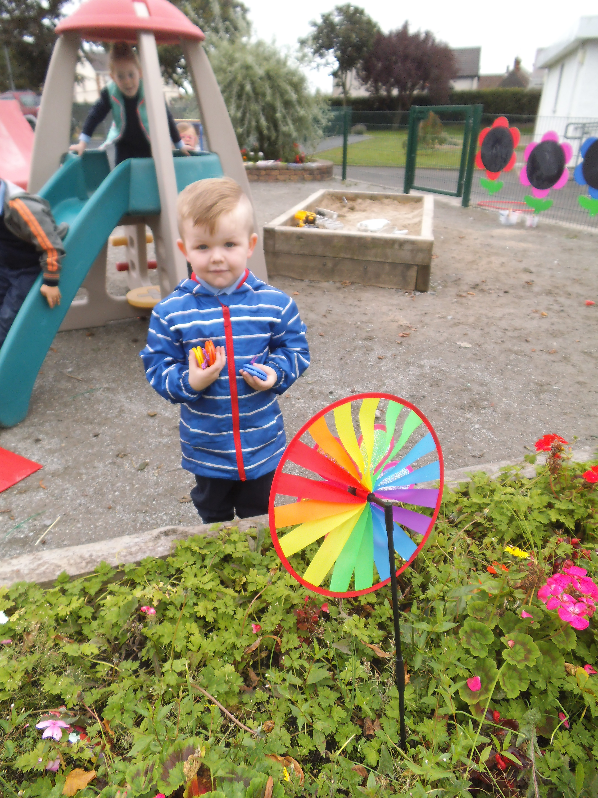
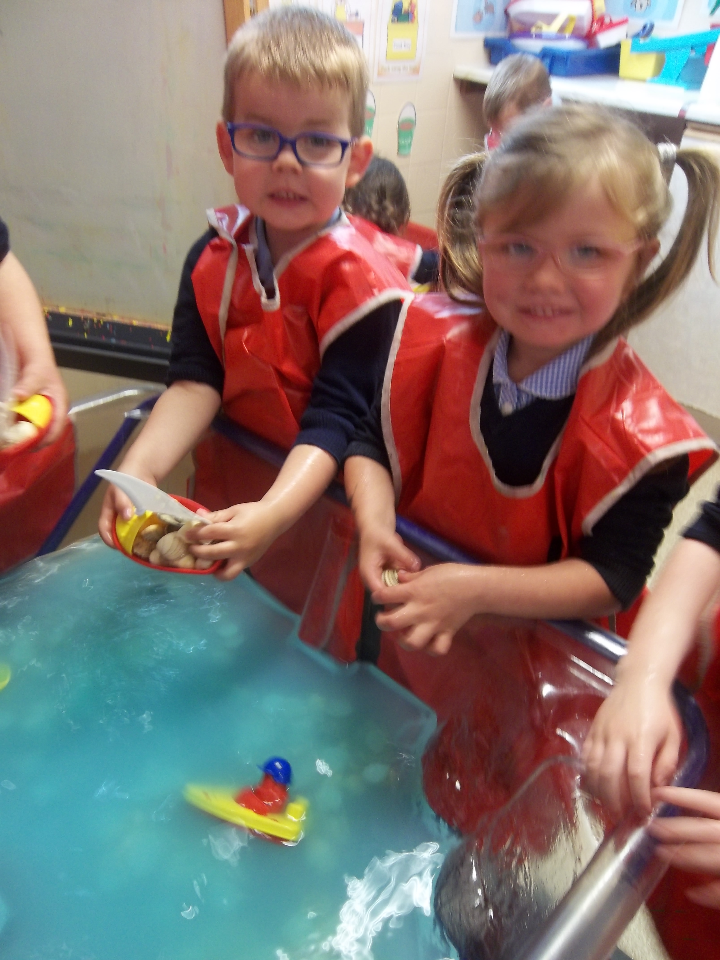
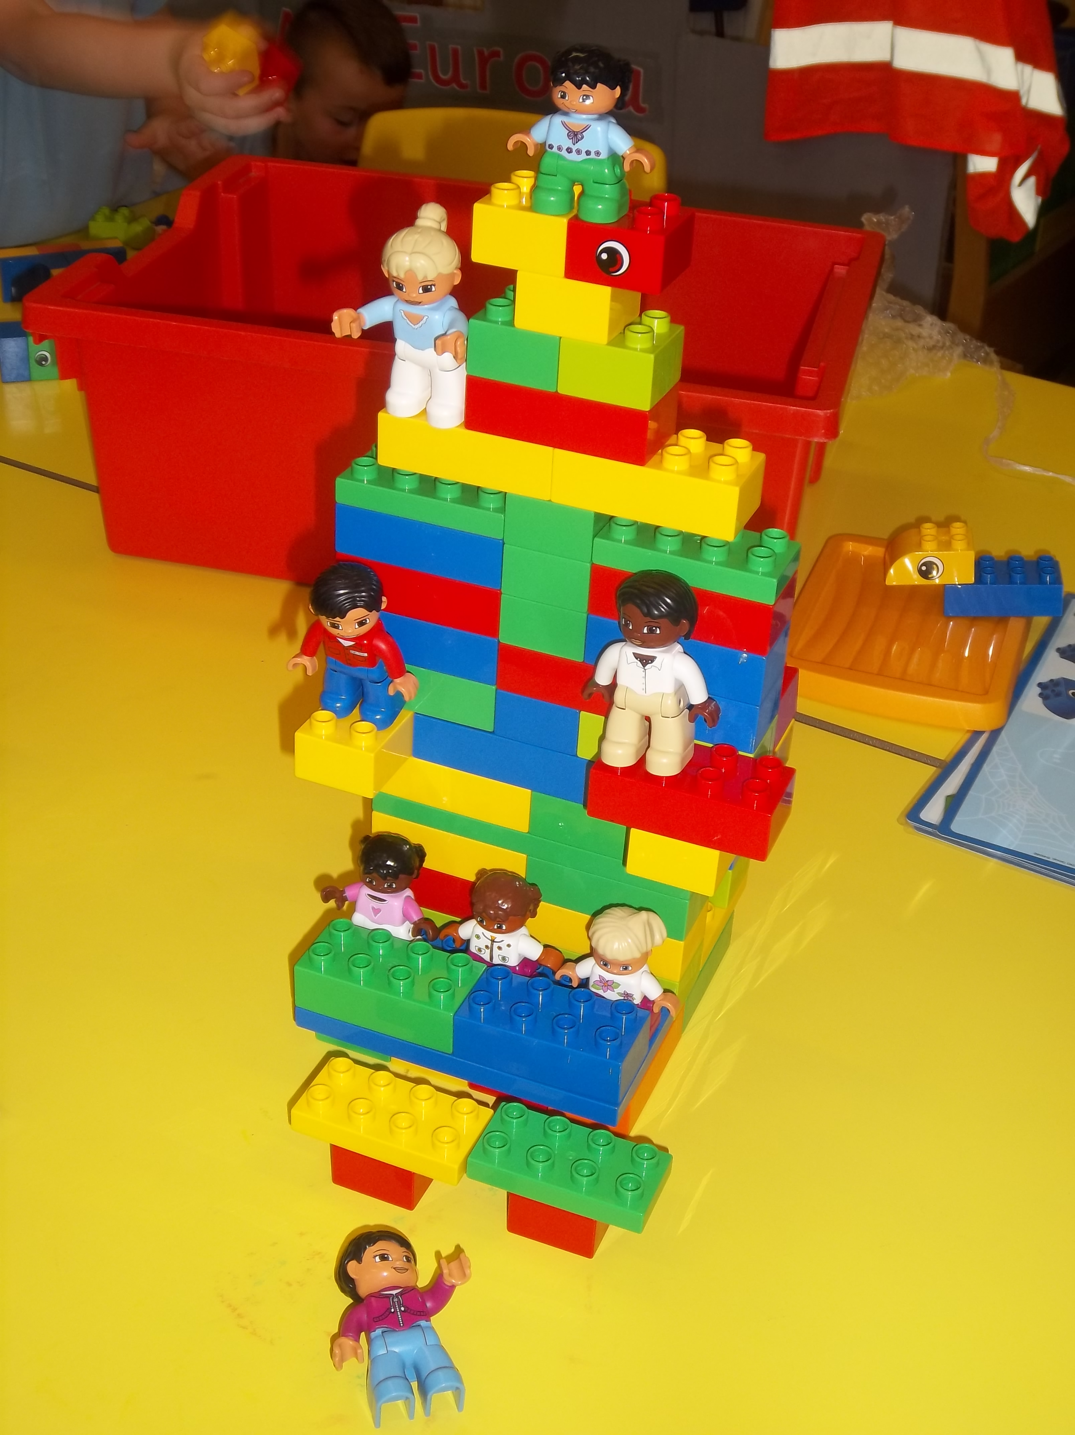

OUR INDUCTION PROGRAMME FOR NEW CHILDREN

Children who have secured a place in Primary One or our Pre-School Group (Reception Class) will be invited to take part in a programme of induction with their parents. We are proud of our Induction Programme, which is unique and goes beyond all requirements for settling in procedures in Northern Ireland. The induction programme is usually held in May and will provide parents with information to prepare for their child starting school. All parents will receive a welcome pack and have weekly contact with our Foundation Stage staff throughout the process. The children will engage in a series of weekly sessions allowing them to become familiar with the setting, staff and their peers. Over the years we have received great feedback about this programme. Our staff recognise the benefits of this programme, reporting that ‘settling-in’ time is greatly reduced and that the transition into our school is smooth and meets the emotional needs of not just the children but also our parents.

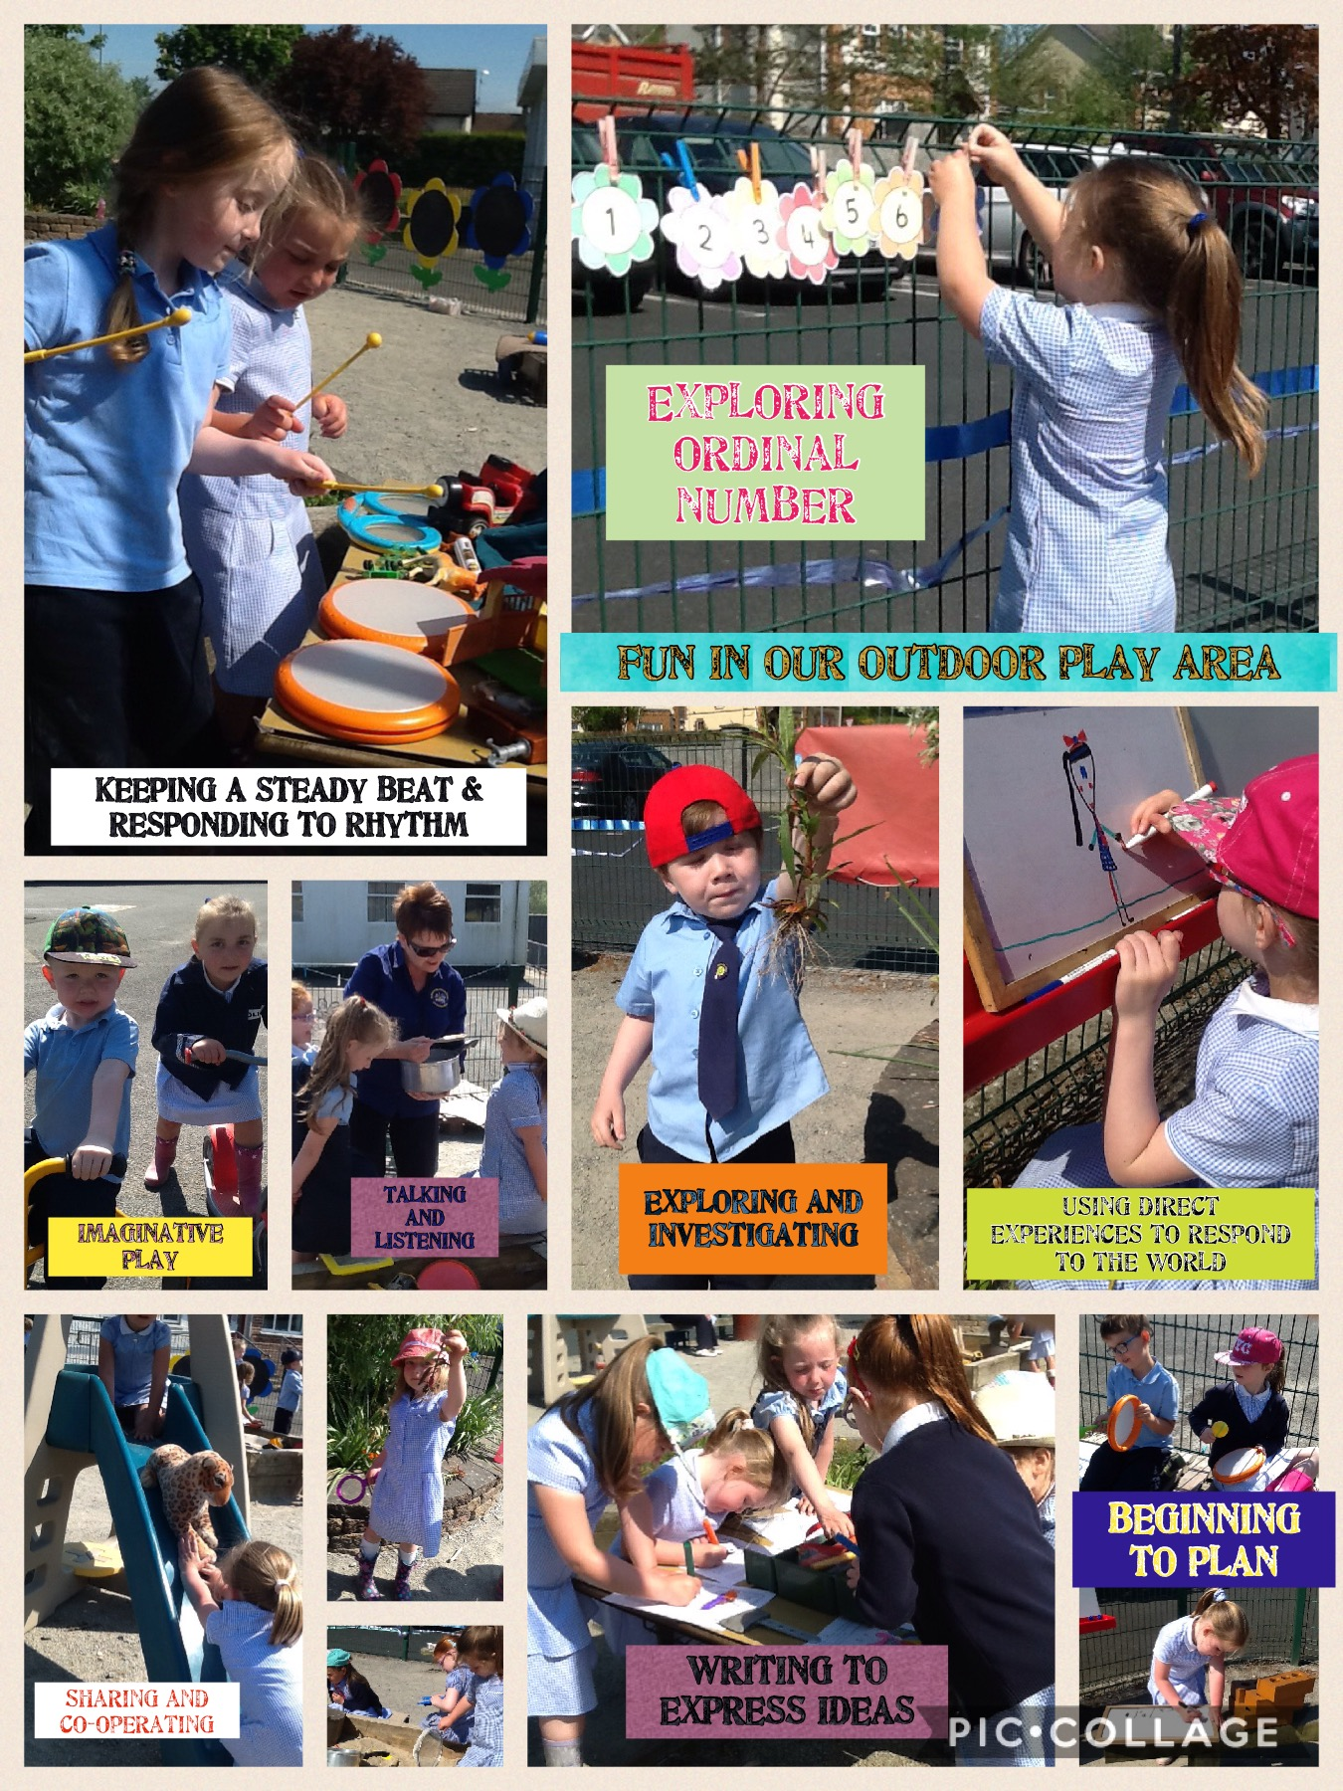

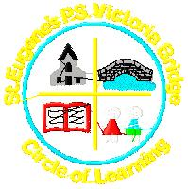
BOARD OF GOVERNORS

CHAIR: Carmel Corry
VICE CHAIR: Debbie Gallagher
SECRETARY: Brian Conlan
TEACHER REPRESENTATIVE: Cliona McDermott
PARENT REPRESENTATIVE: Kelly Boyle
TRUSTEE REPRESENTATIVE: Fr Canning Dermott
TRUSTEE REPRESENTATIVE: Paula Devine
THE DEPARTMENT REPRESENTATIVE: Peter McNulty
EDUCATION AUTHORITY: Patrick Kelly
PRINCIPAL: Laura Gormley

ANCILLARY STAFF

Clerical Officer Mrs. M Gallagher

Cook in Charge Mrs. J McGinley

Caretaker Mr. L Mc Menamin/Mrs. G Boyce
Supervisory Assistants
Mrs. S Preston
Mrs. M Gallagher
Mrs L. McBride

