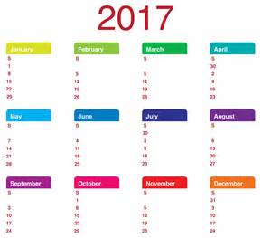
Diary Dates

- Induction for New Children
Wednesday 17th May & Wednesday 24th May
- Walk to School Week
Monday 15th – Friday 19th May
- The Great Shirt Swap
Friday 26th May
- Bank Holiday - SCHOOL CLOSED
Monday 29th May
- Sport’s Day
Sunday 4th June
- Induction @ Holy Cross College for P7 pupils
Monday 5th June
- Fan the Flame Mass for P7
Wednesday 7th June
- Election – SCHOOL CLOSED
Thursday 8th June
- Minecraft Celebration in Sion Mills PS
Friday 9th June
- Redcastle Trip
Wednesday 28th June

May 2017 Newsletter

Milk Money
£4.20 for the month of May, payable now.

Tin Whistle
£5.00 for the month of May, payable now.

First Holy Communion
We are very proud of all of our P4 pupils who received Jesus for the first time on Saturday as they celebrated the Sacrament of the Eucharist, in St Theresa’s Church, Sion Mills. Thankfully we were blessed with fine weather to add to this wonderful occasion and each and every child did themselves and our school proud. The ‘First Communion Class’ also celebrated on Monday with a little ‘party’ in school and got to wear their outfits again to show their friends in other classes. Thank You to Mrs Connolly, Miss Brennan and Mrs Preston for all of their work in preparing the pupils to receive the sacrament.

Morning Drop Off (Breakfast Club)
Our Breakfast Club is proving to be a great success thus far with over a third of our pupils having availed of the service at least once since it began on April 24th.
Remember that the outcome of this trial will inform any decision to provide this service in the future so we would encourage as much use of the facility as possible. The Breakfast Club is open from 8.15am. To avail of the Breakfast Club there is a cost of £1 per child, per day.
Walk to School Week
Next week (Monday 15th – Friday 19th) is ‘Walk to School Week’ with Travelwise NI and we will be encouraging the pupils to walk to school as much as possible. For those who travel too far a distance by car, why not park at the shop or other safe place nearby and walk part of the way?
‘Walking Wednesday’ will be our big drive to walk and staff will gather at Devine’s Mace to meet pupils and set off for a short walk to school at 9.00. Both buses will be dropping off there too on that morning to allow as many of our pupils as possible to walk.

Gemma’s Run/Mindfulness
Mr Gallagher and Miss Brennan will be participating in ‘Gemma’s Run’ in Aghyaran on Friday night. This is an event in memory of Gemma McHale who died in an accident in 2012. Money raised by Gemma’s parents funded the recent and extremely worthwhile ‘Mindfulness’ Programme enjoyed by our P6 & 7 pupils and funds raised in this run will again go towards the ‘Mindfulness’ Programme in our area. If you would like to support this event, Mr Gallagher and/or Miss Brennan can be sponsored via the office and we will pass on all funds to Gemma’s parents. A worthwhile cause we are sure you will agree.

Standardised Tests
Pupils from P3-7 will be completing assessments in Literacy & Numeracy over the course of the next few weeks. These assessments help inform our planning and teaching for next year, as well as indicate to our school how each of our pupils have progressed since May of last year.
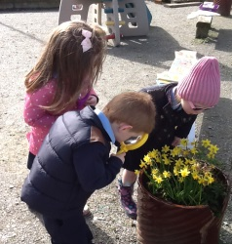
Induction Programme
Thank You to the parents who attended the initial induction meeting with Miss Gormley on Wednesday afternoon. We look forward to welcoming all our new pupils next Wednesday (17th of May) for the first of our Parent and Child sessions. Please remember the Reception children will stay in school until 2.15pm on this day and also on the following Wednesday 24th of May.
Questionnaires
Thank you to everyone who returned a questionnaire last month. The feedback from these was overwhelmingly positive, although there are areas that have been brought to light that will form part of our 3 Year Plan for the development of the school.

Value of the Month
This month’s focus: Honesty. At the end of the month staff will identify a pupil each class who has been particularly good at living out this value.

Prayer of the Month
Please keep note of the prayer for the month of May and say this at home with your child.
The Memorare
Remember O most gracious virgin Mary,
That never was it known,
That anyone who fled to thy protection, implored thy help,
Or sought your intercession, was left unaided.
Inspired with this confidence, I fly unto you
O virgins of virgins my mother
To you I come, before you I stand
Sinful and sorrowful
O mother of the Word Incarnate despise not my petitions
But in your mercy – hear and answer me.
Amen
‘The Great Shirt Swap’
The NI Children’s Hospice provides Children’s Palliative Care for life limited children and their families. This year we are supporting their drive for funds by participating in the ‘Great Shirt Swap’ on Friday 26th May. On the day, pupils (and staff!!) can ‘swap’ their uniform for the brightest possible coloured clothing that they have and donate a minimum of £1 each. All money raised will go to the Children’s Hospice.

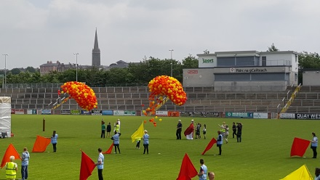
‘Fan The Flame’ Mass
Our P7 pupils will be attending the ‘Fan The Flame’ Mass in Derry on Wednesday 7th June 2017, where they will join with other pupils of their age from Derry, Donegal and Tyrone who have all received the Sacrament of Confirmation this year. Further information will be sent out to parents shortly.

Election Closure
As you are no doubt aware – there will be an election on Thursday 8th June. As we are a Polling Station, this will necessitate the school being closed to all pupils and staff on that day. School will reopen again on Friday 9th June as normal.

Minecraft
On Monday 15th May, our P5-7 pupils will enjoy the 4th of four sessions of Minecraft with Stem Aware. The Virtual Reality version of St Eugene’s is now almost entirely complete. All pupils involved will attend a ‘showcase’ of their work and that of other schools in Sion Mills PS on Friday 9th June. Well done to all of our pupils….or should we say ‘Miners’?

Easter Draw Winners
The Easter Draw helped raise just over £250 for school funds – all proceeds being spent directly on the pupils. We are so grateful for your support. A huge Thank You to all of those parents who donated a prize for the draw as well as to the local businesses that provided prizes too…The Sperrin Restaurant, Omagh , O’Neills, Strabane, Devine’s Mace, Victoria Bridge
Prize Winners were as follows:
Easter Chocolate Hampers: Tyler Flanagan/Jimmy Duddy/Courtney Murray
Sperrin Restaurant Voucher: Bernie Boyle
Luxury Hamper:Sean Darcy
O’Neill’s Football: PJ Gunn
Body Shop Gift Set: Eire Gallagher
Bottle of Wine: Michelle Flanagan
Bottles of Prosecco: Claire Gallagher/Lena Toland
Boxes of Biscuits: Penny McConnell/Mickey McMenamin

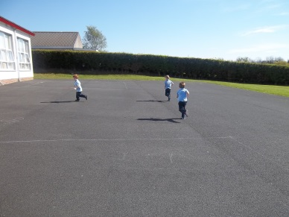
Warm Weather and Sun Protection
The recent warm and sunny spell has brought again into focus the importance of protecting ourselves against the sun. Please remember that school staff are not permitted to apply sun-cream for your child and that a good application of sun-cream before coming to school will be sufficient for the amount of the school day that children spend outdoors. We also encourage the wearing of hats for outdoors.

Cycling Proficiency
Mrs Preston will be assisting pupils towards their Cycling Proficiency this year, with the first session due to take place next week. This session will not require pupils to have their bicycles. Keep an eye on Twitter and/or Facebook for further details on how the programme will run after this.
Choir
We have begun a Choir for children from P3-7. Rehearsals take place on a Friday afternoon with Sonia Hargan, who we are delighted to have leading this activity. Our aim is for as many pupils as possible to be involved – research shows that when pupils are exposed to music and singing, this helps with attainment in school. We would ask that you promote the Choir at home and encourage active involvement, particularly if your child is a reluctant singer.
Sport’s Day – Sunday 4th of June
We plan to hold our annual Sport’s Day on Sunday 4th of June 2017. Each year this event is greatly supported by the families and friends of St Eugene’s PS, we simply could not run the event without you! We are making an appeal for a range of items which will contribute to the success of the day.

We welcome donations for:
- Lucky dip - (small value items such as toys, key rings, colouring pencils etc).
- Bottle Stall - unopened bottles of any kind for our bottle stall, these can be soft drinks, alcohol, condiments, cleaning products, shower gels etc.
- Cake Stall/Coffee Shop - Any donations for our cake stall and coffee shop can be brought to school closer to the date.
- Larger Prizes - If you would like to make a donation for one of our larger prizes such as vouchers, spirits, perfumes, hampers etc these would also be greatly received.

We thank you in advance for your generosity. All money raised on the day will be put into school funds which has helped the children of the school immensely in the past. There will be boxes available in the school foyer for dropping of any donations.

Twitter
We would love to see many more parents and friends follow us at @StEugene58. You can join at www.twitter.com and begin following our school (@StEugene58). New photos added daily!

Facebook
Many of our parents and friends will know that we have recently joined Facebook. We will use our Facebook page to keep you informed of school events and important dates, if you use this social media platform please like our page.

