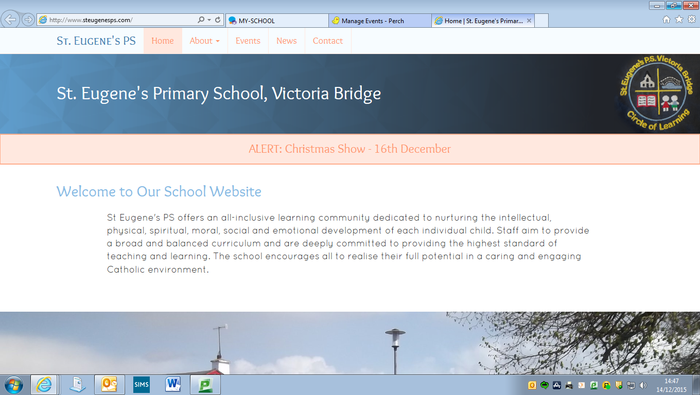

**Diary Dates**

**First Confession**: Wednesday 13th March 7pm

**Sponsored Fitness Day:** Thursday 14th March

**St Patrick’s Day Closure:** Monday 18th March

**Big Pedal:** Monday 25th March – Friday 5th April

**Confirmation**

Our P7 pupils received the Gift of the Holy Spirit in Confirmation on Sunday past, 10th March. The pupils worked hard to prepare themselves for receiving the sacrament and our school community is very proud of them. We hope that each P7 pupil will use the Gifts of the Holy Spirit bestowed upon them to enrich their own lives and the lives of others.

**First Confession**

Mrs Connolly and our P4 pupils are busily preparing to receive the Sacrament of Reconciliation. The pupils will make their First Confession in St Theresa’s Church on Wednesday 13th March at 7pm. All children should be in the Church by 6.45 pm and must wear their full uniform.

We wish all of our P4’s well as they learn to say ‘Sorry’ in a way that brings them closer to God.

**Friends of St Eugene’s Fashion Show – Save The Date!!!**

Our Friends group are excited to announce that we are holding a **Fundraising Fashion Show** in the **Fir Trees Hotel on 11th April @ 7.30pm.**

A number of local businesses have committed to supporting our cause and planning and preparation for this exciting event is well under way. Some of our pupils (and staff!!) as well as parents, friends and past pupils will be strutting their stuff on the catwalk on a night NOT to be missed!

A draw will take place on the night with many fabulous prizes on offer. This is the Friends of St Eugene’s major fundraiser for this year and your presence and support will be greatly appreciated. Everyone welcome so pass on the date to family members, friends and members of our local community and beyond!!

*Tickets for the event will be on sale soon from the school office.*

**Shared Education**

We are delighted that our P6 & 7 pupils have this year again embraced their Shared Education Project with St Patrick’s PS Newtownstewart and Newtownstewart Model PS, exploring the theme of “Flight & Space Travel”. Pupils have had a number of engagements already with two further dates (Wednesday 13th March & Friday 22nd March) to come. To conclude the project for this year, all the pupils involved from the three schools will visit W5, Belfast, on Tuesday 26th March for activities and workshops based around their theme.

**Gaelic Coaching**

We are fortunate to have 2 fantastic coaches working in the school at the minute – Ryan Mayse and Fiachra McNulty who are delivering Gaelic Coaching to our P6/7 class and our P4/5 pupils respectively. These coaching sessions take place on Thursday and Friday mornings and the children are enjoying them very much. Please remember that PE Gear is an important element of PE lessons and that PE lessons are part of the curriculum and should only be missed under medical advice.

**Breakfast Club**

Our Breakfast Club is being very well supported this year and we are delighted to be able to offer this important service at such a keen price. Please remember though – Breakfast Club comes at a cost of £1. Pupils can have a breakfast included in this price if they wish. If pupils do not avail of the ‘breakfast’ element, the cost is still £1.

A growing number of pupils are being dropped off in the mornings before 9.00am. Should you need to drop a child off early, the Breakfast Club facility is available from 8.10 until 9.00 in the morning. We cannot guarantee the supervision of pupils who arrive on to the school grounds before 9.00 and would ask parents to either drop off at Breakfast Club (in the hall) or between 9.00 & 9.15 only.

**Sponsored Fitness Day**

Our Pupil Council are trying to raise additional funds to improve the play facilities that are available in our playgrounds. Whilst existing school funds will go some way to meeting the cost, we are hoping to raise some additional funds to make up some of the shortfall. This is the sole purpose of our ‘Sponsored Fitness Day’ on Thursday 14th March. Pupils will exercise throughout the day and we are asking parents, grandparents and family members to sponsor children to complete their exercises. All funds raised will go into the ‘pot’ to pay for our playground improvements.

Pupils can come to school in their PE Gear and should bring a bottle of water.

**The Big Pedal**

We are working hard to attain further awards from Sustrans, as we aim to encourage our pupils to travel to school ‘actively’.

This month (Monday 25th March – Friday 5th April) sees the SUSTRANS Big Pedal take place. During this fortnight, we are aiming to get as many pupils as possible to travel to school on a scooter or a bicycle. This journey can be a ‘part journey’ for those who live too far away (for example, travelling by car into Victoria Bridge and cycling from the shop).

We will also organise a ‘Cycle/Scoot Morning’ where staff will be on hand to accompany children on a cycle from beside the Community Hall to the school. This will take place on Friday 5th April.

**Attendance**

Recently we have experienced a very worrying drop in our attendance figures. Please note that arriving in late (after registration closes) is recorded as a period of inattendance. If your child is going to be absent, **it is vital that the school are informed either by a phone call on the day, or a note once your child returns to school.**

The EWO (Education Welfare Officer) is able to access our Attendance Data and will shortly be making contact with those families where a pupil or pupils are showing poor attendance.

**Tin Whistle** **£4 for March payable now**

We are fortunate to have Noel Devine’s expertise to help our pupils develop their musical talents at just £1 per week. Tin Whistle is for all pupils from P4-7 and goes a long way to helping our school fulfil our obligations to provide Music as part of the curriculum.

**Sending money into school**

Please ensure that money for milk, dinner, tin whistle etc is sent into school in a clearly marked envelope that includes your child’s name, the amount being paid etc. This allows the school to manage income more effectively and ensures that there is no confusion over money, particularly when money is lost and subsequently found.

**Prayer of the Month**

In school each month we will be focussing upon a different prayer. The children will discuss the prayer in class and at Assembly. Please keep note of the prayer for each month and say this at home with your child.

***March Prayer of the Month: Christ be beside me (St Patrick’s Breastplate)***

Christ be with me,

Christ be beside me,

Christ be before me,

Christ be behind me,

Christ be at my right hand,

Christ be at my left hand,

Christ be with me everywhere I go,

Christ be my friend for ever and ever

*Amen*

**Value of the Month**

Each month we will be concentrating with the children upon a value that we hope the children will show at school and at home. These are listed below. Values will be discussed in class and at Assembly. Each month the staff will identify a member of each class who has been particularly good at living out that value.

This month’s focus: ***Kindness****.*

April – Patience

May - Honesty

June – Courage

*Please discuss these values at home too.*

**MEDICATION IN SCHOOL**

A reminder of very important information regarding Medication in school:

The school can only keep **blue inhalers** on the premises. All other colours must be kept at home. If these need to be administered during the school day, parents must make arrangements to come to the school to do this.

This also applies to any non-prescription medication, eg Calpol (**unless you order it on prescription and it then displays a prescription/pharmacy label**). We cannot store any non-prescription medication.

Please remember that medication….

* Must be stored in a *small ‘lunchbox’ type container with a secure/clip lid*, labelled with your child’s name
* That the *prescription label* is visible on all items
* That you have enclosed a *signed, written note* clearly advising of dosage instruction.

**Milk Money**

Milk Money for Term 3 can now be paid (**total for the term is £11**). Last term we asked that this be paid up front to ensure that we were able to order the correct amount of Milk. You were very supportive of this as parents. This has reduced the amount of milk going to waste. If you wish for your child to have milk during Term 3, please pay this on or before Friday 29th March 2019.

***We will only be able to order milk each week for those who have paid.***