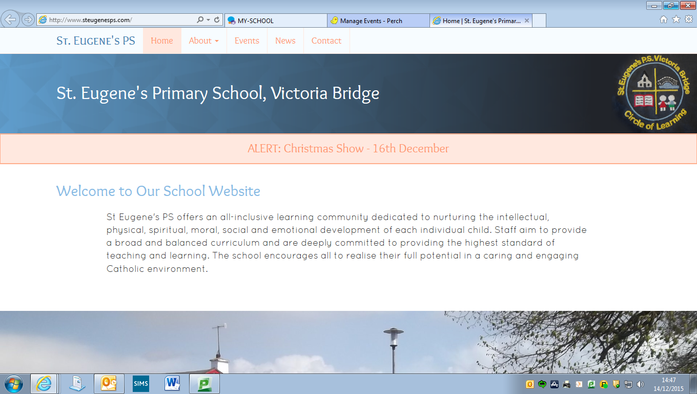

**Diary Dates**

**First Confession**: Wednesday 14th March 6.30pm

**St Patrick’s Day Closure:** Monday 19th March

**School Photographer:** Tuesday 20th March

**P6 Trip to Strabane Academy**: Thursday 22nd March

**Easter Holidays** **begin**: Wednesday 28th March @ 1pm

**Confirmation**

Our P7 pupils received the Gift of the Holy Spirit in Confirmation on Saturday past, 3rd March. The pupils worked hard to prepare themselves for receiving the sacrament and our school community is very proud of them. We hope that each P7 pupil will use the Gifts of the Holy Spirit bestowed upon them to enrich their own lives and the lives of others.

**First Confession**

Mrs Connolly and our P4 pupils are busily preparing to receive the Sacrament of Reconciliation. The pupils will make their First Confession in St Theresa’s Church on Wednesday 14th March at 6.30pm. All children should be in the Church by 6.15 pm and must wear their full uniform.

We wish all of our P4’s well as they learn to say ‘Sorry’ in a way that brings them closer to God.

**Futsal (5 A Side Indoor Football) Success!!!!**

13 of our pupils (7 boys and 6 girls) from P5-7 travelled recently to Omagh Leisure Centre to compete in an IFA organised regional Futsal event (Futsal is 5 a side indoor soccer played with a slightly heavier ball and with a few specific rules). Our boys’ team finished a very creditable 3rd place in their section, missing out on the final by one place and played some great football along the way. Our girls’ team meanwhile finished in 2nd place and thus made the final where they emerged victorious after a penalty shootout win against the reigning NI champions!!! We are so proud of all of the children who participated with such energy and enthusiasm and we look forward to our girls’ team competing in the NI finals in April. Well done to all!!

**School Gates**

On a number of occasions recently we have found our Pedestrian Gate (to the side of our Entrance Gate) open after the pupils have arrived at school in the morning. If you are dropping a child off via this gate, please close the gate over on your way out.

We would also appeal to all parents NOT to park over the yellow box at the small green gate which leads from our front car park to our main door as this prevents other people from safely accessing the gate.

**Dropping Off and Picking Up**

A growing number of pupils are being dropped off in the mornings before 9.00am. **Should you need to drop a child off early, the Breakfast Club facility is available from 8.10 until 9.00 in the morning at a cost of £1.** We cannot guarantee the supervision of pupils who arrive on to the school grounds before 9.00 and would ask parents to either drop off at Breakfast Club (in the hall) or between 9.00 & 9.15 only.

A number of pupils have also been collected early from school. Please remember that learning takes place up until 3.10 (before tidying up) and that frequent early pick-ups can soon amount to quite a considerable amount of missed learning.

**Visiting the school during the school day**

Should you need to visit the school during our normal teaching time (9.15 – 3.15), we would ask that your first port of call be Mrs Gallagher’s office. Mrs Gallagher will be able to deal with most queries and can communicate any important information to teachers at a suitable time. Often the arrival of a parent at a classroom door can distract from the teaching & learning taking place.

**Uniform**

So many of our pupils are arriving at school in full uniform with **black shoes** – thank you for encouraging this at home, the children certainly look much smarter! Please label each part of your child’s uniform to help us identify items as jumpers and ties in particular can get mixed up.

School Ties can often get lost easily too. We have a supply of ties in the school office should you need to purchase one. They are £2.50 (cost price). Mrs Gallagher will be able to help you out should your child need one.

**Tin Whistle** **£4 for March payable now**

We are fortunate to have Noel Devine’s expertise to help our pupils develop their musical talents at just £1 per week. Tin Whistle is for all pupils from P4-7 and goes a long way to helping our school fulfil our obligations to provide Music as part of the curriculum.

**Prayer of the Month**

In school each month we will be focussing upon a different prayer. The children will discuss the prayer in class and at Assembly. Please keep note of the prayer for each month and say this at home with your child.

***March Prayer of the Month: Christ be beside me (St Patrick’s Breastplate)***

Christ be with me,

Christ be beside me,

Christ be before me,

Christ be behind me,

Christ be at my right hand,

Christ be at my left hand,

Christ be with me everywhere I go,

Christ be my friend for ever and ever

*Amen*

**Value of the Month**

Each month we will be concentrating with the children upon a value that we hope the children will show at school and at home. These are listed below. Values will be discussed in class and at Assembly. Each month the staff will identify a member of each class who has been particularly good at living out that value.

This month’s focus: ***Kindness****.*

April – Patience

May - Honesty

June – Courage

*Please discuss these values at home too.*

**Parents’ Support Group**

Many thanks to those parents who expressed an interest in being part of a Parents’ Support Group.

If you are interested in being a member of the Parents’ Support Group either as a committee member or in the role of a volunteer at events, please ring the office and give your name to Mrs Gallagher.

**Shared Education**

Our P5-7 pupils have embarked upon their Shared Education Project with St Patrick’s PS Newtownstewart and Newtownstewart Model PS, exploring the theme of “The Vikings: Raiders or Traders?”. All the pupils involved from the three schools visited W5, Belfast on Wednesday 28th March and have begun establishing groups and getting to know one another. A first Shared Ed learning session has also taken place at Newtownstewart Model PS and we look forward to the project continuing throughout March and April.

**School Photographer**

The school photographer will visit the school on Tuesday 20th March (in the morning). A note will be sent out shortly

**Questionnaires**

We recently sent out questionnaires in relation to our Breakfast Club and After School Activities Provision. We are extremely grateful for the swift return of these, the number of returns and the overwhelmingly positive responses and comments from you our parents.

**IMPORTANT INFORMATION RELATING TO MEDICATION IN SCHOOL**

****Children who require inhalers to be kept in school must have a written note of parental consent. School staff cannot administer any medication but can supervise a child who needs to take an inhaler (only blue type) through the school day.

Parents must make their own arrangements to administer any other form of medication, eg antibiotics, painkillers.

Children must never keep any medication on their person, in their school bag, lunch box or coat pocket. All medication in school is stored safely out of the reach of pupils.

Medication held by the school should be clearly labelled with the child’s name and dosage instructions. If possible it should be in a re-sealable, see through pouch/bag. Your child’s name should be visible on the outside of the bag, as well as on the medication itself.

**Attendance**

Recently we have experienced a worrying drop in our attendance figures. Please remember that continued attendance at school is a key factor in pupil attainment and progress.

Please also note that arriving in late (after registration closes) is recorded as a period of inattendance.

If your child is going to be absent, it is vital that the school are informed either by a phonecall on the day, or a note once your child returns to school.

**Easter Feis**

Our Easter Feis will take place in the Hall on Tuesday 27th March from 9.30am. All parents, family and friends are welcome to join us as we celebrate our pupils’ talents in music, song, drama and prose amongst other things.

**Easter Draw**

Tickets will soon be available for our Easter Draw which will take place at our ‘Feis’ on Tuesday 27th March. Proceeds from the draw will go towards school funds and a charitable donation to Trocaire.

Any donations for prizes will be greatly appreciated – if you are able to donate, or know of a local business that may be willing to provide a prize, please contact the office.

In recent times the response to our various fundraising draws has been absolutely fantastic. We appreciate that it is not always easy to purchase tickets and will therefore send home a book of only 5 tickets for each family. Should you wish to purchase more, please let Mrs Gallagher know.

**Athletics Club**

This activity is proving very popular with our pupils and we regularly have approx. 25 pupils in attendance. Athletics was due to finish on Wednesday 7th March, but will now also take place on Wednesday 14th March, when it will end for the term. Well done to all of the boys and girls who have participated this term!

**Mindful Club**

This activity was also due to finish this week, today, Thursday 9th March but will run for 1 further week, meaning that it will finish on Thursday 16th March. We are delighted that this is on offer for our pupils and it is great to see pupils learning to be ‘mindful’ and focus upon good mental (and not just physical) health.

**After Schools & Breakfast Club**

After Schools on a Monday with Danny Gallagher and Mrs O’Kane will finish on Monday 12th March. After Schools on from Tuesday – Thursday (2.15-3.15) will finish for the term on Thursday 22nd March.

Breakfast Club will operate up until and including Wednesday 28th March.

**Non Uniform Day – Trocaire**

Each Lent, we aim to raise awareness of the plight of children in poorer countries. One way to do this is through the presence of a Trocaire Box in each classroom. Pupils can make a small donation to their class Trocaire box should they wish. We will also use some funds from our Easter draw to supplement what we raise. In addition, we intend to have a ‘Non Uniform Day’ on the last day of this term, Wednesday 28th March. Pupils can come to school in their ‘casual’ clothes, pay a £1 ‘fee’ and all proceeds will go to Trocaire.

