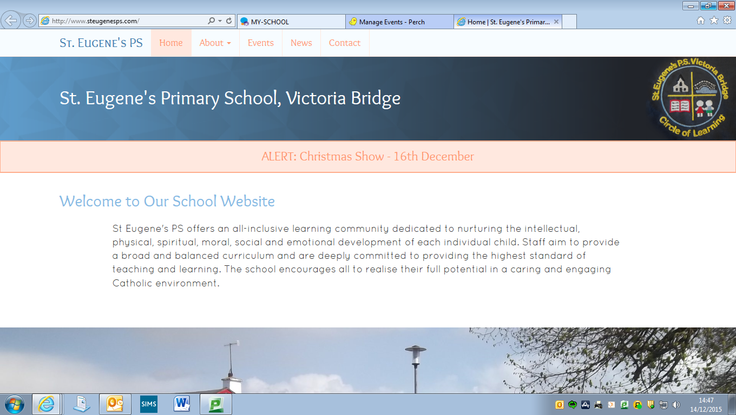

It is hard to believe that we are now at the end of another school year. What a year this has been, from new leadership to new staff, new developments and experiences for our children and many community celebrations along the way. We are so thankful for all of the wonderful times we experienced here at St Eugene’s PS, prior to the school closures in March. This year has been particularly challenging for our pupils, parents, staff and Governors due to the Covid-19 pandemic. I would like to thank you all for your hard work and dedication throughout the most difficult days. Together we have got through this and together we can face whatever the future may bring. We recognise that it has not been easy having to home school for more than one full term and I must commend you on your efforts. Whether your child has done 3 or 4 hours a day, half an hour, or even gone a week without completing school work, you can be sure that there will have been many incidental learning experiences along the way that you may not give yourself credit for. It is time now for our children to take a rest from the paper work packs and online tasks and enjoy the summer holidays. I hope that you our parents and carers enjoy the break from the books too, stay safe and we look forward to welcoming you back for the new school year.

Miss Gormley

Newsletter 10

June 2020

**TRANSFER TEST**

Our P6 parents will now be aware that Loreto Convent Grammar and CBS Omagh have both made the decision to cancel the transfer test for this year. At this point no change in transfer arrangements has been communicated from Strabane Academy. Prior to these announcements Mr Gormley prepared transfer paper packs, these can still be used for revision and to keep up learning over the summer if you so wish. Post Primary schools will release their admissions criteria in the autumn term and these will reflect any decision not to offer the transfer test.

**SUMMER LEARNING FOR CHILDREN ENTERING PRIMARY SEVEN**

The Department of Education is offering free access to the Mathematic Mastery programme over the summer holidays for our current P6 children who are moving into P7. Mathematics Mastery provides a structured programme for literacy and numeracy and step by step guides for parents.

The numeracy activities allow opportunity for discussion and independent practical tasks which encourage mathematical thinking and video clips are also provided for support. The numeracy tasks cover aspects of number, shape and space and measures. The literacy activities provide opportunity for structured activities, reading, discussion, prediction and comprehension all based on selected texts which are provided.

Parental access to the programme is straight forward, there is no need to register just access the ‘Free Covid-19 Resources’ at the top of the Mathematics Mastery homepage:

**https://www.mathematicsmastery.org/**

There are two maths packs, one has the guidance pages and the other the pupil facing resources. Parents need to access both packs as the pupils’ packs do not make sense without the guidance. To reduce printing, the guidance packs can be accessed digitally as they contain embedded video links. There are also two literacy packs with the guidance included. An additional information page on Mathematics Mastery can be found on the back page of this newsletter.

**FIRST HOLY COMMUNION**

Fr Canning has provisionally scheduled the postponed First Holy Communion for Thursday 8th of October at 5pm, subject to covid-19 restrictions. The Sacrament will take place in St Theresa’s Church, Sion Mills and attendance will be restricted to the immediate family of the children receiving the Sacrament. Please note that only children from our school will receive the Sacrament on this date. If you wish to discuss the First Holy Communion further, please contact Fr Canning directly.

**MATHLETICS**

Children in P2 – P7 have passwords for Mathletics which can be accessed through Google or by downloading the app. This app will continue to be available over the summer holidays and is great for a little burst of revision on a rainy day!

**MY SCHOOL**

If your child wishes to access MySchool over the summer holidays it is important to remember that all Passwords expire 120 days after they were last reset. If a password expires, or needs to be reset and the user knows their old password they can go to: <https://services.c2kni.net/ums>

Enter the required details and the new password will be registered.

**THE REOPENING OF SCHOOLS FOR 2020/2021**

I wrote to you at the beginning of June to explain that I was awaiting further guidance from the Department of Education on the reopening of schools. On the 11th of June I wrote to Minister Weir to express my deep concerns about the lack of information available to Boards of Governors, school leaders and parents on the reopening of schools. The Department of Education NI have since sent guidance on Friday 19th June entitled “Coronavirus (COVID 19)- Northern Ireland Reopening Schools Guidance New School Day”.

This document answers many of the questions that school leaders have been seeking the answers to, however, there are still a number of issues that have yet to be addressed. One of the certainties is that **Primary Seven (our current P6 group) will return to school on Monday 24th of August 2020**. It is still unclear if transport or school meals will be provided during this week, therefore, parents may have to provide these for their child throughout this week.

The guidance also outlines the requirement that children must adhere to 1 metre social distancing from each other and 2 metre social distancing from staff. If this restriction remains in place it will mean that schools will only be able to accommodate half of the class in ‘protective bubbles’ at a time. This could result in children attending school for two days a week, remaining in their protective bubbles and engaging in remote learning on the other days. We realise that this is not the ideal situation for children, families or staff but the safety and well-being of our children will be key in the return to school. Remote learning would be different from that experienced to date, with new training actioned, more structure in place and a requirement for pupils to actively engage in submitting work and receiving feedback.

It is important to realise that the science is changing all of the time and the guidance could well have changed significantly by the 1st of September, as we have two full months ahead. Whilst we plan for a hopeful full reopening, the guidance issued on the 26th has been used to form the contingency plan outlined above. We will provide a clear update and more definite guidance to all parents in August when we hope that all of the dots will then be joined by the Department of Education and the Education Authority.

It is vital that we have up to date mobile phone numbers for our new text system, correct email and home addresses for ALL PARENTS/CARERS. If any of your details have changed in the last 3 months, please make sure you communicate these via email to [lgormley873@c2kni.net](mailto:lgormley873@c2kni.net).

**THANK YOU AND GOOD BYE TO MISS MCCAY**

Our Primary Seven children are not the only ones who are saying goodbye to our school this month. Miss McCay will also complete her contract on the 30th of June. She will be sorely missed by staff, pupils and parents alike. Miss McCay has brought so much to our school throughout this academic year, her dedication and commitment has been remarkable and she has had a huge impact on our Key Stage Two class. We know that Mr Gormley will miss her support immensely in the new school year. We wish Miss McCay the very best and hope that she will always be a friend of our school – thank you for everything Miss McCay!

**GOODBYE TO OUR CLASS OF 2020**

Our current Primary Seven children have reached the end of their primary school days and we hope that it has been a pleasant journey during your time at St Eugene’s PS. The Board of Governors and staff would like to take this opportunity to wish you the very best as you transition to post-primary school. We are sad to see you go but also confident that you have the skills and grounding you need for pastures new. It hasn’t been the end to your journey that you would have expected but we hope that the surprises here in school today have given you a send-off to remember. We are so proud of everything that you have achieved and we look forward to hearing all about how you are getting on in your new schools. Please be assured that Mr Gormley and Miss Gormley have been working together with your new schools to communicate all the necessary information they need to make the transition a smooth one. Remember you will always be part of our St Eugene’s PS community and we encourage you not to be a stranger!

**GOODBYE AND GOOD LUCK TO ADAMNAN, BOBBY, CODY, MOLLIE, PENNY, EIRE AND LORCAN!**

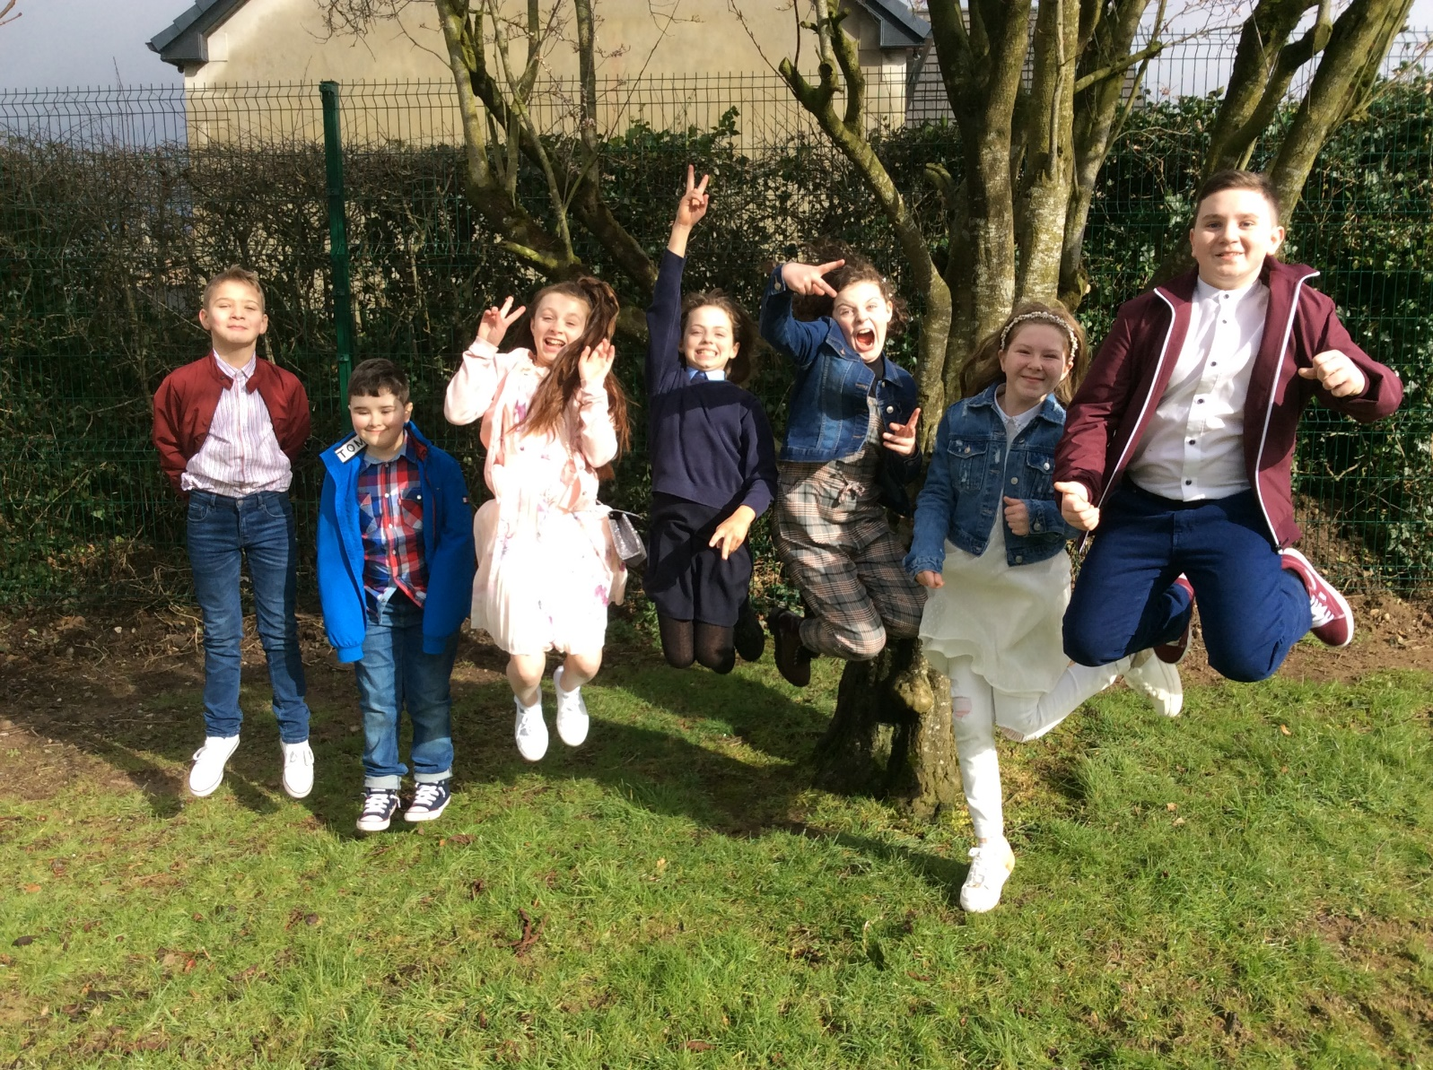

**MATHEMATICS MASTERY GUIDE FOR P6 PARENTS**

**Mathematics Mastery** provides a structured programme for **literacy** and **numeracy** and step by step guides for parents.

The **numeracy** activities allow opportunity for discussion and independent practical tasks which encourage mathematical thinking and video clips are also provided for support. The numeracy tasks cover aspects of number, shape and space and measures.

The **literacy** activities provide opportunity for structured activities, reading, discussion, prediction and comprehension all based on selected texts which are provided.

Parental access to the programme is straight forward, there is no need to register just access the **‘Free Covid-19 Resources’** at the top of the **Mathematics Mastery** homepage:

<https://www.mathematicsmastery.org/>



There are two maths packs, one has the guidance pages and the other the pupil facing resources. Parents need to access both packs as the pupils’ packs do not make sense without the guidance. To reduce printing, the guidance packs can be accessed digitally as they contain embedded video links.

There are also two literacy packs with the guidance included.

**Year 5** [approximately equivalent to year 6 NORTHERN IRELAND CURRICULUM] **Printable packs**

• Maths Year 5 Weeks 1-4 Guidance pack (easy for parents/guardians to guide learning)

• Maths Year 5 Weeks 1-4 Pupil pack

• Maths Year 5 Weeks 5-9 Guidance pack (easy for parents/guardians to guide learning)

• Maths Year 5 Week 5-9 Pupil pack

• English Year 5 Workbook (week 1-4) (guidance included)

• English Year 5 Workbook (week 5-9) (guidance included)