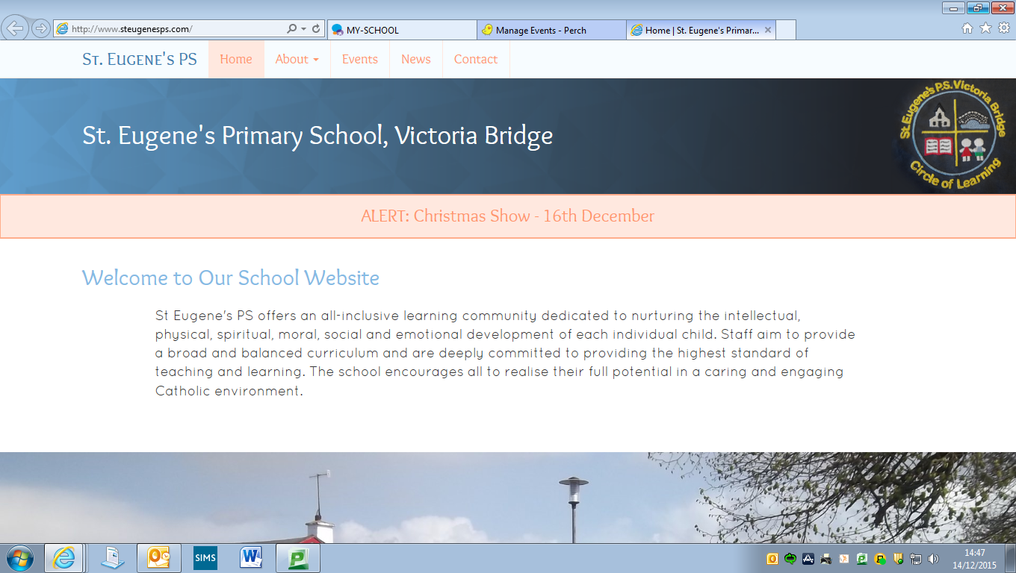

**Diary Dates**

**Catholic Schools’ Week: 27th January – 2nd February**

**Road Safety Quiz: Thursday 25th January**

**P7 Transfer Meetings for Parents: Wednesday 30th January**

**Service of Light: Wednesday 6th February**

**P6 Intergenerational Project: Monday 11th February**

**Confirmation: Sunday 10th March**

**First Confession: Wednesday 13th March**

**First Holy Communion: Saturday 11th May**

**Happy New Year!!**

Welcome back everyone and a very happy new year to you all. We hope that all of you had a wonderful Christmas. We are delighted to see all of our pupils back at school safe, well and full of enthusiasm for the term ahead.

**Term Dates**

**Monday 7th January – Wednesday 17th April 2019**

* **Mid-term break:**

Thursday 14th – Tuesday 19th February (inclusive)

* **St Patrick’s Day:**

Monday 18th March.

* **Easter Holidays** **begin**: Wednesday 17th April @ 1pm

**Attendance**

Please remember that if your child is absent from school, the school should be notified by telephone (on the day) or via a note upon return to school. An increasing number of pupils are returning to school after absence with no note and as a staff we have not been informed as to where they are on days when they are sick. Absences that occur and are unexplained will come to the attention of the Education Welfare Officer who will then get in touch at home.

**Tin Whistle**

We welcome Noel Devine back for the New Year to tutor our pupils on the Tin Whistle. This is a fabulous opportunity for our pupils to develop their musical talents under Noel’s patient guidance. £1 per week.

**Milk Money**

£11 for the term, payable now.

**Inter-Generational Project**

Primary Six children will participate in an artistic workshop on 11th February. This wonderful workshop will be run by Gloria Perry in our school hall and will involve our P6 pupils creating their very own sculpture with the help of Gloria and a grandparent, aunt or uncle. Children will then join the primary six groups from Sion Mills PS, St Theresa’s PS, Glebe and St Columba’s PS, Clady to showcase their work later in the month.

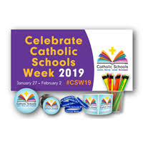

**Catholic Schools’ Week 2019 – Grandparents’ Assembly**

Catholic Schools’ Week will run again this year from 27th January – 2nd February. An important part of this week is Grandparents’ Day when we focus as a school upon the important role that grandparents can play in the lives of our pupils and their families. A special Grandparents’ Assembly will be held in the hall on the morning of Friday 1st February (exact time tbc). All grandparents and any other family members are very welcome to attend. Do you know of someone in the Victoria Bridge community who is a grandparent but perhaps their grandchildren do not attend our school or even live nearby? Please extend an invitation to those people also.

**Pupil Assessments**

Our P4 and P6 pupils will participate in some assessments during the first week of February. These assessments will be completed on the computer and are designed to identify our pupils’ strengths in key areas, as well as areas for development. The data gained from these assessments will assist our teachers in planning for the remainder of the year and beyond. If you would like to find out anything further about the assessments, please do not hesitate to get in touch.

**After School Sports**

After School Sports activities will resume on Tuesday 15th January from 3.15pm – 4.15pm PE Gear required!

**Art Club**

Miss Brennan will be running an Art Club for the next 6 weeks on a Thursday (final class on Thursday 28th February). This will be open to P3-7 pupils and will run from 3.15pm – 4.15pm at a cost of £1 per session. If you would like your child to attend, please complete and sign the reply slip sent home already.

**Swimming**

Our P5-7 pupils have almost reached the end of their swimming lessons for the year. They have all enjoyed progress and had a great time at Riversdale each Friday. We thank the pool staff for their dedication to helping our pupils improve and we congratulate our pupils on how well they have done.

Remember that lessons are £1 per week and any outstanding amounts should be paid by no later than Friday 25th January 2019.

**Fit Fridays**

As part of our drive to improve health & well-being amongst our pupils and school community, we have established a number of walk to school events, all of which will take place on Fridays. There will be one ‘Fit Friday’ per month with dates as follows:

Feb – 8th, Mar – 1st, Apr – 5th, May – 3rd & June – 7th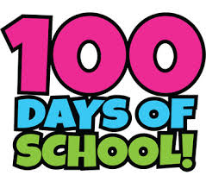

**100th Day of school**

On 8th February 2019, our school will reach its 100th day of this academic year. In each classroom on this day, the children will engage in a number of fun, maths related activities all about the number 100. Keep an eye on Facebook & Twitter for some photos!

**Buddy Reading**

Each pupil in our school has been ‘paired up’ with a ‘Buddy’. This week we began our regular ‘Buddy Reading’ sessions, where pupils take the time to read to each other, discuss books and hopefully establish a good relationship with each other.

**Transfer Meetings**

Mr Gallagher will meet with parents of all P7 pupils (regardless of whether pupils sat exams or not) on Wednesday 30th January in relation to applications for Post Primary School Transfer this year. A letter has been issued to indicate the time of each individual parent meeting.

**Christmas Draw**

A huge thank you to everyone who contributed a prize for our Christmas Draw, no matter the size or value. To all of those who purchased tickets on the night also – we are very grateful. The Christmas Draw raised a **fantastic £1340** for school funds and this money will be **spent directly on our pupils**, helping to reduce the cost of school trips, provide resources for delivering the curriculum and more.

**Friends of St Eugene’s Group**

Our new ‘Parents’ group have had a number of meetings and are currently planning an event for the Spring Term. New members are always welcome…contact the office should you wish to get involved.

School Calendars – produced by the group as an initial fundraiser are still available from the office at a very reasonable £3.50. **Remember – all funds raised go directly back into supporting our pupils so please support**!

**Board of Governors**

Our Board of Governors has recently been reconstituted and as part of this process, there are some new faces and current members have also taken on new and/or different roles. The makeup of our Governors is as follows:

Chairperson: Mrs Carmel Corry, Vice Chair: Mrs Debbie Gallagher, Secretary: Mr Brian Conlan

Other Board Members: Fr Canning, Mrs Paula Devine, Mr Peter McNulty, Mr Patsy Kelly, Mrs Ursula Grimley (Parent Representative), Miss Gormley (Teacher Representative) & Mr Gallagher

**Prayer of the Month**

In school each month we will be focussing upon a different prayer. The children will discuss the prayer in class and at Assembly. Please keep note of the prayer for each month and say this at home with your child.

***January Prayer of the Month: Prayer to The Guardian Angel***

Angel of God,

My Guardian dear,

To whom God’s love commits me here,

Ever this day be at my side,

To light and guard,

To rule and guide. Amen.

**Value of the Month**

Each month we will be concentrating with the children upon a value that we hope the children will show at school and at home. These are listed below. Values will be discussed in class and at Assembly. Each month the staff will identify a member of each class who has been particularly good at living out that value.

This month’s focus: ***Responsibility****.*

February – Love March – Kindness April – Patience May – Honesty June – Courage

*Please discuss these values at home too.*

**Post Primary School Open Days/Evenings**

Parents/Guardians of P7 pupils are invited to visit schools to help in making a decision in relation to the Transfer process in February. Relevant events are as follows…

Saturday 13th January – Sacred Heart College: 10.00am – 1.00pm. Principal’s address @ 10.15am

Saturday 19th January – Omagh CBS: 9.45am – 12.30pm. Principal’s address @ 10.00am

Saturday 19th January – Holy Cross College, Strabane: Principal’s addresses @ 10.00am & 1.00pm

Wednesday 23rd January – Loreto Grammar, Omagh: 5.00pm – 8.00pm

Thursday 24th January – Strabane Academy: Principal’s address @ 7.00pm

**Service of Light**

The Service of Light for P7 pupils who will be receiving the Sacrament of Confirmation in March, will take place in St Theresa’s Church, Sion Mills on Wednesday 6th February at 7.00pm.

Whilst this short service is primarily for P7 pupils and their parents, all members of the school community are welcome to attend.

**Christmas Mass**

We had a very enjoyable Advent Mass for pupils and staff in school on Friday 14th December. Our thanks to Fr Canning for celebrating the Mass with our pupils, who responded very well to him. We were so proud of how they sang, read, shared in prayer and listened throughout the Mass. We look forward to another Mass during Holy Week.



**Sacrament of Penance**

Fr Canning will visit the school on Thursday 7th February to provide an opportunity for P5 - P7 pupils to receive the Sacrament of Penance.

**Shared Education**

We are delighted that our school has again been granted funding to engage in a Shared Education Project with two nearby primaries, Newtownstewart Model PS and St Patrick’s PS Newtownstewart. The funding will allow our pupils and staff to work alongside pupils and staff from both of these schools and to develop a partnership with both schools. With financial cuts taking effect upon the education sector at present, this is a welcome boost as the funding will allow for staff training, the purchase of resources and exciting learning opportunities for our pupils. P6 & 7 pupils will engage in a project during this term with more details to follow.

**Minecraft/Stem Aware**

Last year our P5/6/7 pupils benefitted from an exciting Stem Aware Project using Minecraft to explore Maths. The pupils worked together to ‘build’ a model of the Titanic and their work was showcased along with that of other local schools during an event at Sion PS, during March 2018.

We are delighted that our P5/6/7 pupils will this year again get the chance to work with Stem Aware to develop their Mathematical Skills and learn more about working in a team though the medium of ICT.

Sessions with Paul from Stem Aware will begin later this term.

**Seismic Citizenship**

P6 & P7 pupils are currently engaged in a project entitled Seismic Citizenship, in which they are learning about some Spanish speaking countries and the threat of earthquakes in certain countries such as Mexico and Colombia.

This week our children’s Spanish speaking link tutors will visit the school to work with our pupils, share some information about their own countries and learn a little about life in St Eugene’s PS

A further element of the project involves our pupils being challenged to build a model of an ‘Earthquake resistant’ building. Entries from all of the schools involved will be judged at W5 in Belfast during a day in which the project will reach its end and the work of all schools will be celebrated.

Our pupils and staff involved have been invited to attend the final day at W5 on **Thursday 14th February**. P6 & 7 will be accompanied by Miss Brennan and Mrs O’Kane on their trip.

**150 Hours Outside Project**

#150hoursoutside Project has been set up with the aim of getting children to spend more time outdoors - worldwide. The challenge is to spend 150 hours outside during 2019, with the overall goal being that all participants together achieve 1 million hours’ outdoors. Miss Gormley’s class joined the challenge on the 7th of January and last week the children in her class managed to clock up 5 hours outside. The children will track their outdoor hours each week and we will keep you posted on their progress throughout the year!

**Library Van**

The Mobile Library Service will resume monthly visits on Wednesday 30th January 2019. Please inform any members of the local and wider community whom you know may be interested that they can avail of the service when it visits our school, should they wish to borrow or return books.