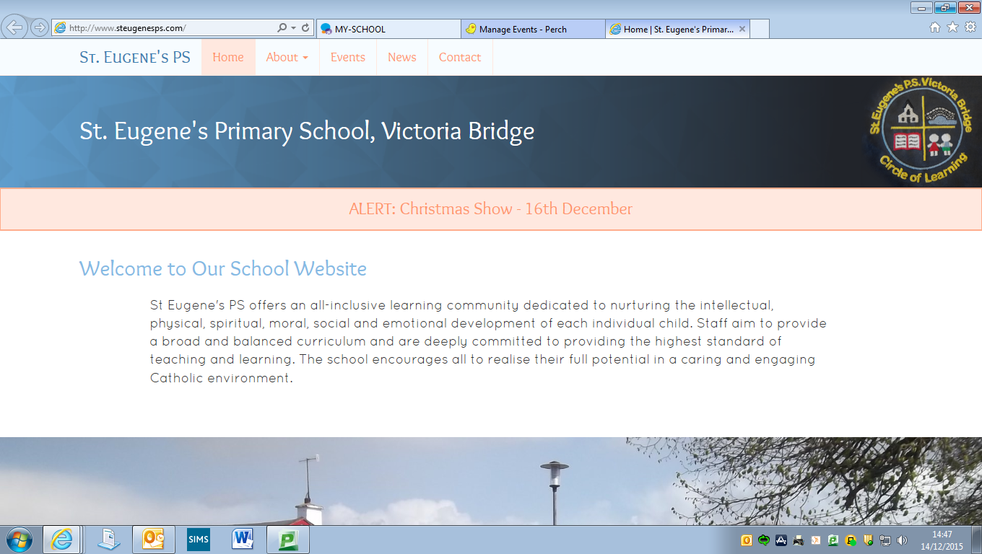

**Diary Dates**

**Catholic Schools’ Week: 28th January – 3rd February**

**Service of Light: Wednesday 24th January**

**Road Safety Quiz: Thursday 25th January**

**P7 Transfer Meetings for Parents: Wednesday 31st January**

**P6 Intergenerational Project: Monday 12th February**

**School Photographer: Monday 26th February**

**Confirmation: Saturday 3rd March**

**First Holy Communion: Saturday 12th May**

**Happy New Year**

Welcome back everyone and a very happy new year to you all. We hope that all of you had a wonderful Christmas. We are delighted to see all of our pupils back at school safe, well and full of enthusiasm for the term ahead.

**Term Dates**

**Thursday 4th January – Wednesday 28th March 2018**

* **Mid-term break:**

Thursday 15th – Monday 19th February (inclusive)

* **St Patrick’s Day:**

Monday 19th March.

* **Easter Holidays** **begin**: Thursday 29th March @ 1pm

**Tin Whistle**

We welcome Noel Devine back for the New Year to tutor our pupils on the Tin Whistle. This is a fabulous opportunity for our pupils to develop their musical talents under Noel’s patient guidance. £1 per week. Tin Whistle will resume on Tuesday 16th January for our P4-7 pupils.

**Milk Money**

£12 for the term, payable now.

**Inter-Generational Project**

Primary Six children will participate in an artistic workshop on 12th February. The workshop will be run by Gloria Perry in our school hall and will involve our P6 pupils creating their own sculpture with the help of Gloria and a grandparent, aunt or uncle. Children will then join the primary six groups from Sion Mills PS, St Theresa’s PS, Glebe and St Columba’s PS, Clady to showcase their work later in the month.

**Pupil Assessments**

Our P4 and P6 pupils will participate in some assessments during the first week of February. These assessments will be completed on the computer and are designed to identify our pupils’ strengths in key areas, as well as areas for development. The data gained from these assessments will assist our teachers in planning for the remainder of the year.

If you would like to find out anything further about the assessments, please do not hesitate to get in touch.

**After Schools**

After School Sports activities will resume with Danny Gallagher on a Monday 15th January from 3.15 – 4.15. We are delighted that Danny is delivering this for the pupils and would strongly encourage any pupils from P3-7 who are not currently attending to come along and join in the fun. PE Gear required!

Athletics Club has also begun with Mr Gallagher on a Wednesday for P4-7 pupils. Again…. we encourage as many pupils as possible to participate. Each session costs 50p.

**Gaelic Coaching**

P6 & 7 pupils have resumed Gaelic Football Coaching with Conor Gormley. This activity has now changed from a Wednesday to a Thursday and takes place between 11.15 & 12.15. PE Gear is necessary for this activity, especially a suitable waterproof jacket or hoodie as the children will be outdoors when it is dry and not too cold! Our P5 pupils will also join these sessions in the week beginning Monday 15th January.

**Rugby Coaching**

Strabane Rugby Club are providing our P6 & 7 pupils with free coaching in the basic skills of rugby. Sessions will take place on a Friday between 11.15 & 12.15. PE Gear is necessary for this activity too, especially a suitable waterproof jacket or hoodie as the children will be outdoors when it is dry and not too cold! The sessions will focus upon ball skills, coordination, handling skills and use of space and will be non-contact.

**Prayer of the Month**

In school each month we will be focussing upon a different prayer. The children will discuss the prayer in class and at Assembly. Please keep note of the prayer for each month and say this at home with your child.

***January Prayer of the Month: Prayer to The Guardian Angel***

Angel of God,

My Guardian dear,

To whom God’s love commits me here,

Ever this day be at my side,

To light and guard,

To rule and guide.

Amen.

**Value of the Month**

Each month we will be concentrating with the children upon a value that we hope the children will show at school and at home. These are listed below. Values will be discussed in class and at Assembly. Each month the staff will identify a member of each class who has been particularly good at living out that value.

This month’s focus: ***Responsibility****.*

February - Love

March - Kindness

April – Patience

May - Honesty

June – Courage

*Please discuss these values at home too.*

**Post Primary School Open Days/Evenings**

Parents/Guardians of P7 pupils are invited to visit schools to help in making a decision in relation to the Transfer process in February. Relevant events are as follows…

Saturday 13th January – Sacred Heart College: 10.00am – 1.00pm. Principal’s address @ 10.15am

Saturday 20th January – Omagh CBS: 10.00am – 1.00pm. Principal’s address @ 10.00am

Saturday 20th January – Holy Cross College, Strabane: 10.00am – 1.00pm. Principal’s address @ 10.00am

Wednesday 24th January – Loreto Grammar, Omagh: 6.00pm. Principal’s address @ 6.30pm (Parents of P6 pupils also welcome).

Thursday 25th January – Strabane Academy: 7.00pm

**Transfer Meetings**

Pupils who sat Entrance Examinations for Grammar Schools in November will receive their results on Saturday 27th January. Mr Gallagher will meet with parents of all P7 pupils (regardless of whether pupils sat exams or not) on Wednesday 31st January in relation to applications for Post Primary School Transfer this year. A letter will be issued shortly to provide further information and to indicate the time of each individual parent meeting.

**Christmas Draw**

A huge thank you to everyone who contributed a prize for our Christmas Draw, no matter the size or value. To all of those who purchased tickets on the night also – we are very grateful. The Christmas Draw raised a fantastic £1,148.31 for school funds and this money will be spent directly on our pupils.

**Service of Light**

The Service of Light for P7 pupils who will be receiving the Sacrament of Confirmation in March, will take place in St Theresa’s Church, Sion Mills on Wednesday 24th January at 7.00pm.

Whilst this short service is primarily for P7 pupils and their parents, all members of the school community are welcome to attend.

**Parents’ Support Group**

We are investigating the possibility of establishing a Parents’ Support Group to complement the work of the school and to strengthen the school community as a whole.

If you are interested in being a member of the Parents’ Support Group either as a committee member or in the role of a volunteer to assist at events, please ring the office and give your name to Mrs Gallagher.

**Christmas Mass**

We had a very enjoyable Advent Mass for pupils and staff in school on Friday 15th December. Our thanks to Fr Canning for celebrating the Mass with our pupils, who responded very well to him. We were so proud of how they sang, read, shared in prayer and listened throughout the Mass. We look forward to another Mass during Holy Week.

**Sacrament of Penance**

Fr Canning will visit the school on Friday 19th January to provide an opportunity for P6 & P7 pupils to receive the Sacrament of Penance.

**Shared Education**

We are delighted that our school has been granted funding to engage in a Shared Education Project with two nearby primaries, Newtownstewart Model PS and St Patrick’s PS Newtownstewart. The funding will allow our pupils and staff to work alongside pupils and staff from both of these schools and to develop a partnership with both schools. With financial cuts taking effect upon the education sector at present, this is a welcome boost as the funding will allow for staff training, the purchase of resources and exciting learning opportunities for our pupils.