- Children can still access their school accounts through ‘My School’. The easiest way to access this is to Google ‘My School’ and select the
‘Login - My School’ option. The top search is usually the one to select so that the child’s logon screen is visible.
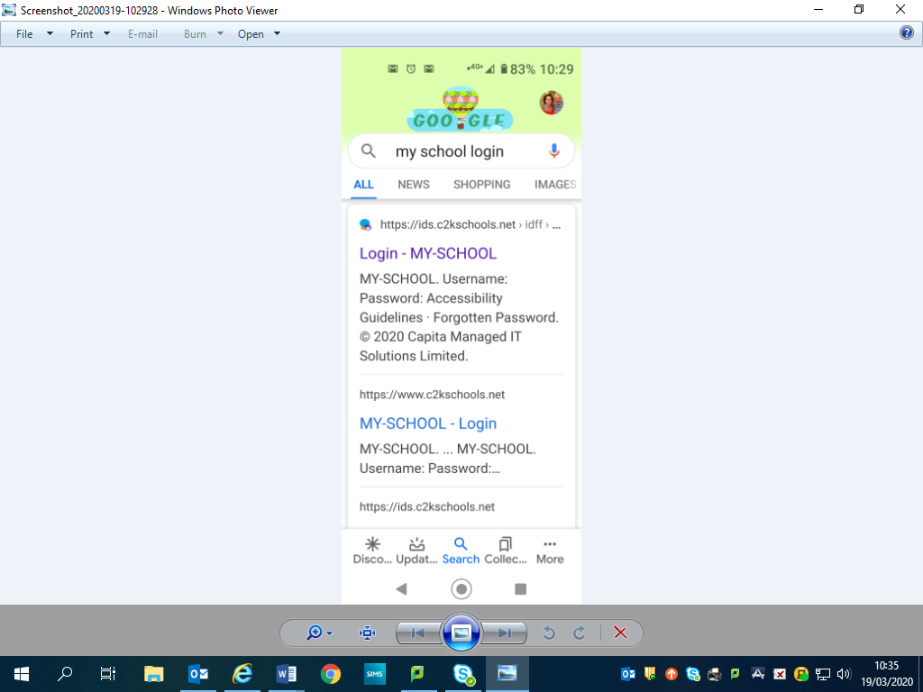

- All children’s log on passwords have been reset to Password (capital P). They will possibly need to reset this when they try to log on at home. Use the enclosed log on card to write down this new password.

- All children in Primary 2 – 7 also have access to the online ‘Mathletics’ programme. The logon details for this are also enclosed. The website link is printed at the bottom of the logon card.

- School Email Address:

info@steugenesps.strabane.ni.sch.uk

- Teachers’ Email Addresses:

cbrennan207@c2kni.net

lgormley873@c2kni.net

dconnolly699@c2kni.net

tgormley142@c2kni.net

