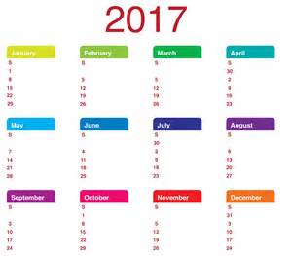
February 2017 Newsletter

Diary Dates
Mid Term Break: Thursday 16th February – Monday 20th February (inclusive

- Inter-Generational Workshop (Gloria Perry)
Wednesday 15th of February
- Election –School Closed!
2nd March
- Fair Trade Fortnight
27th February – 12th March
- Global Learning Twilight
Tuesday 7th March
- First Confession
Thursday 9th March
- Confirmation
Sunday 12th March at 11am

Milk Money
£3.40 for the month of February, payable now.

Tin Whistle
£4.00 for the month of February, payable now.

Confirmation
Confirmation for our P7 pupils takes place on Sunday 12th March, in St Theresa’s Church, Sion Mills. The pupils have begun their preparations for receiving the Holy Spirit and are very excited about their big day.
As part of the preparations for Confirmation, pupils, parents and sponsors are required to attend a rehearsal in St Theresa’s on Monday 6th March @ 7pm. Please remember that when deciding upon a sponsor for your child, that all sponsors need to be over 16 years of age and be practising Catholics.

First Confessions
First Confessions will take place on Thursday 9th March, in St. Theresa’s Church, Sion Mills at 6.30 pm. All children should be in the Church by 6.15 pm and must wear their full uniform.

Prayer of the Month
In school each month we will be focussing upon a different prayer. The children will discuss the prayer in class and at Assembly. Please keep note of the prayer for each month and say this at home with your child.

February Prayer of the Month: Prayer to the Holy Spirit
Holy Spirit, I want to do what is right,
Help me.
Holy Spirit, I want to live like Jesus,
Guide me.
Holy Spirit, I want to pray like Jesus,
Teach me.
Amen

Lexia Programme
We have been fortunate to have gained access to a Literacy Intervention Programme (Lexia) as a trial from now until 31st March 2017. The programme is computer based and is designed to assist pupils with phonics, reading strategies and comprehension.
We have 30 places at the minute and some of our pupils will soon receive a username and password so that they can access the programme both in school and at home. A letter will be sent out to those pupils whom we feel might best benefit from a place on the programme.

Linguistic Phonics

We would like to thank all of the parents/grandparents who attended the Linguistic Phonics workshop on Thursday afternoon. It is always so encouraging to see such a large number of people interested in promoting reading and writing at home. Miss Gormley hosted the event which highlighted many of the strategies used in the P1/P2 classroom, as well as offering tips and advice on how to help your child at home. We hope that the workshop has been of benefit to those who attended and that you now have a deeper understanding of what Linguistic Phonics is all about.

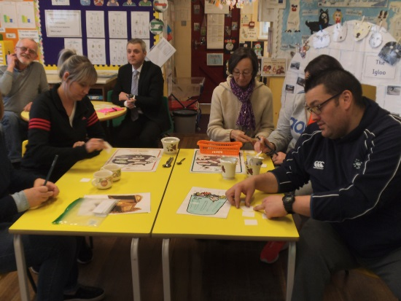

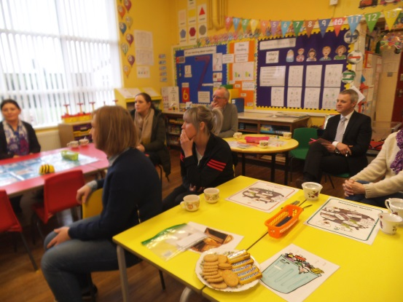

Election Closure
As you are no doubt aware – there will be an election on Thursday 2nd March. As we are a Polling Station, this will necessitate the school being closed to all pupils and staff on that day. School will reopen again on Friday 3rd March as normal.

Global Learning
We are delighted to announce that Saint Eugene’s Victoria Bridge is now a Global Learning School. We qualified as a level one school in January 2017. Global learning will be promoted through many aspects of our school life, allowing the pupils to gain an understanding of the world beyond our school. We will celebrate the Fairtrade Fortnight from 27th February – 12th March. On Tuesday 7th of March will we act as a host school for other Global Learning schools in the area, this will be a chance to look at where we are in terms of Global Learning and to consult with others on how we move forward. The event will be facilitated by a member of staff from the Global Learning Programme NI.

Value of the Month
Each month we will be concentrating with the children upon a value that we hope the children will show at school and at home. These are listed below. Values will be discussed in class and at Assembly. Each month the staff will identify a member of each class who has been particularly good at living out that value.
This month’s focus: Love.

Catholic Schools’ Week Assembly
A huge thank you to all of those members of our school community (in particular our Grandparents) who joined with the pupils and staff on Friday last (3rd February) to celebrate Catholic Schools’ Week and Grandparents’ Day through our Assembly. It was wonderful to see such a turnout and fantastic for our pupils from Reception – P7 to have an audience for their prayers, songs, poems and art. Your presence brought a smile to the faces of our pupils – we hope that they did the same for you.
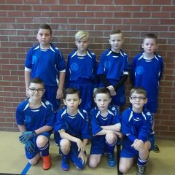
Gaelic Football 5 A Side
Well done to our P6 and P7 boys who represented the school superbly at the recent 5 A Side Indoor Gaelic Tournament in the Station Centre in Omagh. The team improved with every match and the boys enjoyed an enjoyable morning. We are very proud of their effort, commitment and positive attitude.

After School Activities P4-7
We are delighted to have extended our After School Activities provision for P4-7 pupils to include Soccer (with Sion Swifts) on a Wednesday from 3.15 – 4.15 and Gaelic Football (with St Eugene’s GAC Newtownstewart & Conor Gormley) on a Thursday from 3.15 – 4.15. These activities will run until the Wednesday (5th April) and Thursday (6th April) before Holy Week. If your child is attending, please ensure that they are adequately dressed as activities will take place outdoors as far as possible.

Cross Country
8 of our pupils are travelling to Holy Cross College, on Friday 10th February to compete in a Cross Country event. Many of our P5-7 pupils tried out for the team, which was great to see. Unfortunately not everyone could be selected. We wish every success to our P7’s – Jason, Courtney, Darci, Reuben and Orla as well as P6 pupils – Connor, Kelan and Caitlyn. Good Luck!

Congratulations
Congratulations to Jason Spence who has been selected to play for Finn Harps Academy at U11 age group. Jason is one of five Sion Swifts players who make up a strong panel of 24 Harps players. They will attend coaching on Sundays in Ballybofey and will play in tournaments like the Galway Cup later in the year.

Twitter
St Eugene’s has now entered into the world of Twitter!! For those of you who make use of this social media platform, we can be followed at @StEugene58. We will use Twitter to showcase lots of the fantastic work that our pupils and staff are engaged in….
For those of you who do not use Twitter – you can join at www.twitter.com and begin following our school. We hope to have our ‘tweets’ available through the school website too www.steugenesps.com in the near future.

Inter-Generational Project Reminder
Primary Six children will participate in an artistic workshop on 15th February. The workshop will be run by Gloria Perry. Children will then join the primary six groups from Sion Mills PS, St Theresa’s PS, Glebe and St Columba’s PS, Clady to showcase their work on Wednesday 22nd February.

