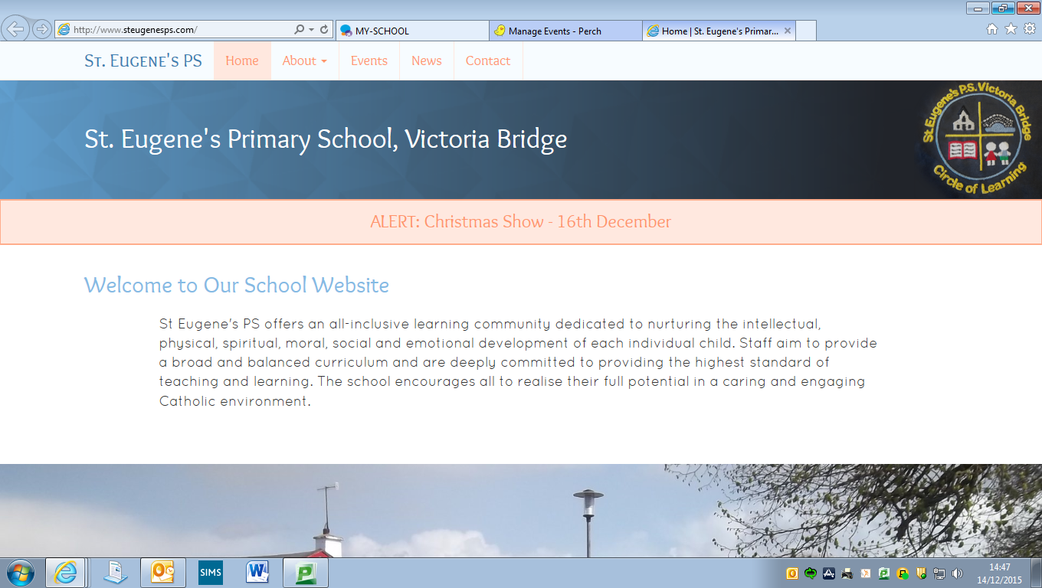

**Diary Dates**

**School Photographer:** Monday 25th February

**P6 Intergenerational Project Celebration:** Tuesday 26th February

**Fit Friday Walk to School**: Friday 1st March

**Ash Wednesday:** Wednesday 6th March

**World Book Day**: Thursday 7th March

**Confirmation:** Sunday 10th March 11am

**Sponsored Fitness Day**: Thursday 14th March

**St Patrick’s Day Holiday**: Monday 18th March

**Pupil Council Led Fundraiser – Support needed!!!**

Our Pupil Council have now turned their attentions from recycling to the outdoor facilities in the school and are aiming to improve the experience for pupils at play during break and lunch. Pupil Council members have consulted with all pupils to identify playground markings that they would like to have in the yard and a quote for the cost has been sourced. We are aiming to invest in these markings through **school funds** and **applications for Lottery funding** but we will still need to **raise some additional funds** to meet the cost. To help with this, the Pupil Council are organising a ‘Sponsored Fitness Day’ in school on Thursday 14th March. (see attached letter). All money raised on this day will go directly towards improving the outdoor play experience for our pupils – please give what you can as every penny counts!!

**Grandparents’/Catholic Schools’ Week Assembly**

Thank You to those of you who joined with us in celebration of Catholic Schools’ Week earlier this month – our thanks most especially to our Grandparents, whom we were particularly celebrating. The Assembly was a lovely occasion for our school community and we hope that all of you who attended had an enjoyable morning.

**Sickness/Illness**

We have recently experienced a higher than usual frequency of pupils who have been ill with vomiting and/or diarrhoea. To help prevent the spread of infection, please follow the Public Health Agency advice – **Pupils should not return to school until 48 hours after the LAST episode of vomiting and/or diarrhoea.** Not 48 hours after the FIRST episode.

**Uniform**

So many of our pupils are arriving at school in full uniform with black shoes – **thank you** for encouraging this at home, the children certainly look much smarter! Please label each part of your child’s uniform to help us identify items as jumpers and ties in particular can get mixed up.

**Tin Whistle** **£3 for February payable now**

We are fortunate to have Noel Devine’s expertise to help our pupils develop their musical talents at just £1 per week. Tin Whistle is for all pupils from P4-7 and goes a long way to helping our school fulfil our obligations to provide Music as part of the curriculum.

**School Photographer**

The school photographer will visit the school on Monday 25th February (in the morning).

**Picture Book Author Visit to Miss Gormley’s Class!!!**

Well known children’s picture book author and illustrator Catherine Rayner will visit our school next Wednesday 27th February from 1pm. Catherine will visit Miss Gormley’s class to talk to the children about her job, read some of her books and give the children some tips on creating their own illustrations. A letter will be sent home shortly with a little more information.

**Inter-Generational Project**

Primary Six children have already participated in an artistic workshop with Gloria Perry in our school hall, creating their own sculpture with the help of Gloria and a grandparent, aunt or uncle. Next week, (Tuesday 26th Feb) the children will join the primary six groups from Sion Mills PS, St Theresa’s PS, Glebe and St Columba’s PS, Clady to showcase their work. A letter will be sent home shortly with further information.

**Gaelic Coaching**

P6 & 7 pupils have begun Gaelic Football Coaching with Ryan Mayse from St Eugene’s GAC Newtownstewart. This activity takes place on a Friday between 11.15 & 12.15. P4 & 5 are also enjoying a block of Gaelic Football lessons with Fiachra McNulty. These will take place each Thursday from 9.30-10.30. **PE Gear is necessary for this activity, especially a suitable waterproof jacket or hoodie** as the children will be outdoors when it is dry and not too cold!

**Please remember that PE is part of the curriculum and is not an optional activity.**

**Prayer of the Month**

In school each month we will be focussing upon a different prayer. The children will discuss the prayer in class and at Assembly. Please keep note of the prayer for each month and say this at home with your child.

***holy spiritFebruary Prayer of the Month:* Prayer to the Holy Spirit**

Holy Spirit, I want to do what is right, Help me.

Holy Spirit, I want to live like Jesus, Guide me.

Holy Spirit, I want to pray like Jesu Teach me.

Amen.

**Value of the Month**

Each month we will be concentrating with the children upon a value that we hope the children will show at school and at home. These are listed below. Values will be discussed in class and at Assembly. Each month the staff will identify a member of each class who has been particularly good at living out that value.

This month’s focus: ***Love****.*

March – Kindness April – Patience

May – Honesty June – Courage

*Please discuss these values at home too.*

**Friends of St Eugene’s PS**

Our recently formed support group will be meeting again at 7.15pm on Tuesday 26th February in the main school building. All new members are welcome to attend.

The Friends Group are planning an exciting, ambitious, whole school, community event for April which we will let you know about very soon.

**Shared Education**

We are delighted that our school has this year again been granted funding to engage in a Shared Education Project with two nearby primaries, Newtownstewart Model PS and St Patrick’s PS Newtownstewart. The funding will allow our pupils and staff to work alongside pupils and staff from both of these schools and to develop a partnership with both schools. Primary 6 and 7 will shortly begin a project on the theme of flight and space travel, with activities in each of the three schools, plus a trip for all 3 schools. More details to follow soon.