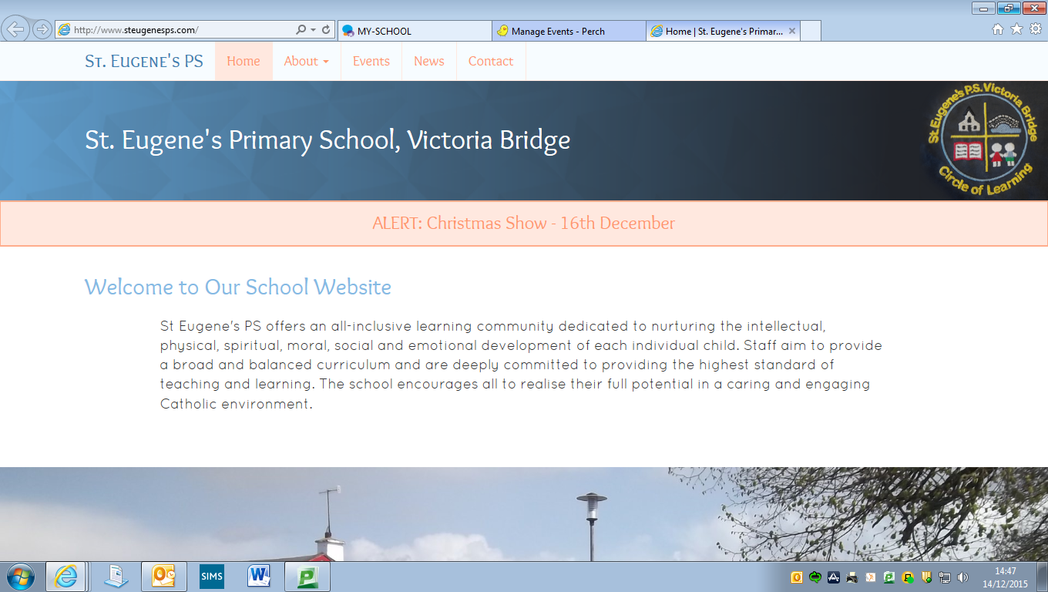

**Diary Dates**

**P6 Intergenerational Project:** Monday 12th February

**Ash Wednesday:** 14th February

**School Photographer:** Tuesday 20th March

**Linguistic Phonics Workshop for P1/2 Parents:** Monday 26th February 2.15-3.15

**Confirmation:** Saturday 3rd March 11am

**Term Dates**

**Thursday 4th January – Wednesday 28th March 2018**

* **Mid-term break:**

Thursday 15th – Monday 19th February (inclusive)

* **St Patrick’s Day:**

Monday 19th March.

* **Easter Holidays** **begin**: Wednesday 28th March @ 1pm

**Education Funding Crisis**

You may or may not be aware that the Education Authority recently refused to approve the Financial Budgets of 632 schools in Northern Ireland. At a time when funding in Education is already insufficient this is a very serious and worrying development.

If the present situation continues, pupils will suffer, as schools will no longer be able to provide adequately for the needs of the children in our care.

We would urge you to read carefully the information on the back of this month’s newsletter and make every effort to attend the public meeting advertised.

**School Gates**

On a number of occasions recently we have found our Pedestrian Gate (to the side of our Entrance Gate) open after the pupils have arrived at school in the morning. If you are dropping a child off via this gate, please close the gate over on your way out.

We would also appeal to all parents NOT to park over the yellow box at the small green gate which leads from our front car park to our main door as this prevents other people from safely accessing the gate.

**Dropping Off and Picking Up**

A growing number of pupils are being dropped off in the mornings before 9.00am. Should you need to drop a child off early, the Breakfast Club facility is available from 8.10 until 9.00 in the morning at a cost of £1. We cannot guarantee the supervision of pupils who arrive on to the school grounds before 9.00 and would ask parents to either drop off at Breakfast Club (in the hall) or between 9.00 & 9.15 only.

A number of pupils have also been collected early from school. Please remember that learning takes place up until 3.10 (before tidying up) and that frequent early pick-ups can soon amount to quite a considerable amount of missed learning.

**Visiting the school during the school day**

Should you need to visit the school during our normal teaching time (9.15 – 3.15), we would ask that your first port of call be Mrs Gallagher’s office. Mrs Gallagher will be able to deal with most queries and can communicate any important information to teachers at a suitable time. Often the arrival of a parent at a classroom door can distract from the teaching & learning taking place.

**Sickness/Illness**

We have recently experienced a higher than usual frequency of pupils who have been ill with vomiting and/or diarrhoea. To help prevent the spread of infection, please follow the Public Health Agency advice – **Pupils should not return to school until 48 hours after the LAST episode of vomiting and/or diarrhoea.** Not 48 hours after the FIRST episode.

**Grandparents’/Catholic Schools’ Week Assembly**

Thank You to those of you who joined with us in celebration of Catholic Schools’ Week on Friday morning – our thanks most especially to our Grandparents, whom we were particularly celebrating. The Assembly was a lovely occasion for our school community and we hope that all of you who attended had an enjoyable morning.



**Uniform**

So many of our pupils are arriving at school in full uniform with black shoes – thank you for encouraging this at home, the children certainly look much smarter! Please label each part of your child’s uniform to help us identify items as jumpers and ties in particular can get mixed up.

School Ties can often get lost easily too. We have a supply of ties in the school office should you need to purchase one. They are £2.50 (cost price). Mrs Gallagher will be able to help you out should your child need one.

**Pupil Council**

Miss Gormley has been meeting with our Pupil Council in recent weeks and the children are beginning the process of identifying their different roles and responsibilities as well as earmarking aspects of school life that they might hope to change. We look forward to hearing their ideas and opinions!

**Athletics/Cross Country**

This After School Activity is proving popular and has given pupils an opportunity to identify if they have a desire and/or ability to compete on an Athletic level. A number of pupils who attend have expressed a desire to compete at Cross Country. Many of these pupils will attend an event at Holy Cross College on Friday 9th February between 10.00 and 12.30, where they will challenge themselves against others and of course the route!!

The Cross Country event is quite challenging but we are delighted that so many children are interested in giving it a go. We wish them the best of luck!

**Tin Whistle** **£4 for February payable now**

We are fortunate to have Noel Devine’s expertise to help our pupils develop their musical talents at just £1 per week. Tin Whistle is for all pupils from P4-7 and goes a long way to helping our school fulfil our obligations to provide Music as part of the curriculum.

**Inter-Generational Project**

Primary Six children will participate in an artistic workshop on 12th February. The workshop will be run by Gloria Perry in our school hall and will involve our P6 pupils creating their own sculpture with the help of Gloria and a grandparent, aunt or uncle. Children will then join the primary six groups from Sion Mills PS, St Theresa’s PS, Glebe and St Columba’s PS, Clady to showcase their work later in the month. A letter will be sent home shortly with further information

**Gaelic Coaching**

P6 & 7 pupils have resumed Gaelic Football Coaching with Conor Gormley. This activity has now changed from a Wednesday to a Thursday and takes place between 11.15 & 12.15. **PE Gear is necessary for this activity, especially a suitable waterproof jacket or hoodie** as the children will be outdoors when it is dry and not too cold! Our P5 pupils will also join these sessions in the week beginning Monday 15th January.

**Rugby Coaching**

Strabane Rugby Club are providing our P6 & 7 pupils with free coaching in the basic skills of rugby. Sessions will take place on a Friday between 11.15 & 12.15. **PE Gear is necessary for this activity** too, especially a suitable waterproof jacket or hoodie as the children will be outdoors when it is dry and not too cold! The sessions will focus upon ball skills, coordination, handling skills and use of space and will be non-contact.

**Prayer of the Month**

In school each month we will be focussing upon a different prayer. The children will discuss the prayer in class and at Assembly. Please keep note of the prayer for each month and say this at home with your child.

***February Prayer of the Month:* Prayer to the Holy Spirit**

***holy spirit***Holy Spirit, I want to do what is right,

Help me.

Holy Spirit, I want to live like Jesus,

Guide me.

Holy Spirit, I want to pray like Jesus,

Teach me.

Amen.

**Value of the Month**

Each month we will be concentrating with the children upon a value that we hope the children will show at school and at home. These are listed below. Values will be discussed in class and at Assembly. Each month the staff will identify a member of each class who has been particularly good at living out that value.

**

This month’s focus: ***Love****.*

March - Kindness

April – Patience

May - Honesty

June – Courage

*Please discuss these values at home too.*

**Parents’ Support Group**

Many thanks to those parents who expressed an interest in being part of a Parents’ Support Group.

If you are interested in being a member of the Parents’ Support Group either as a committee member or in the role of a volunteer to assist at events, please ring the office and give your name to Mrs Gallagher.

To those who have already volunteered, we will be in touch soon to begin establishing the group.

**Shared Education**

We are delighted that our school has been granted funding to engage in a Shared Education Project with two nearby primaries, Newtownstewart Model PS and St Patrick’s PS Newtownstewart. The funding will allow our pupils and staff to work alongside pupils and staff from both of these schools and to develop a partnership with both schools. The project is in the final stages of planning (due to begin at the end of the month) and a letter with further information will be issued shortly.

**School Photographer**

The school photographer will visit the school on Tuesday 20th March (in the morning). Please note the change in date from that previously communicated in the January Newsletter.

**Gaelic Football**

8 boys from P6 & P7 recently attended the Cumann Na mBunscol Indoor Gaelic 5 A Side Tournament in the Station Centre, Omagh. Although the team did not progress to the next round, we are very proud of the boys and proud too of their performance. As usual, the behaviour of the boys was exemplary and they had a great time. We hope to attend some further tournaments as the academic year progresses and we look forward to the team enjoying a little more success.

**Education Funding Crisis**

Dear Parent,

**Invitation to public meeting to address school cuts:**

**Thursday 8th February 4pm-5pm**

You will be aware that the education budget is currently in crisis. Despite rising pupil numbers in Primary and Nursery Schools in recent years, school budgets have not received investment reflective of this increasing demand.  The situation has worsened over the past year. Only last week, 632 schools received the news that their budgets had not been approved plunging them further into financial crisis.

This is unacceptable.  Without immediate intervention, the education of thousands of pupils throughout Northern Ireland is at risk. In light of the severity of the situation at hand, we would urge you to attend an important public meeting next week with school leaders, parents and governors at Arvalee school:

**Thursday 8th February 2018**

**4pm-5pm**

**Arvalee School, Omagh**

**(Strule Campus, Gortin Road, Omagh, BT79 7DH)**

Please circulate this information widely. Investment in education must be a priority;

* This year there are 3,000 additional children in nursery and primary schools with no funding;
* Reductions in funding have resulted in a cut of at least £61 per pupil in primary schools, £83 in nursery schools for full time pupils and £25 per pupil in real term for post primary;
* Despite announcements of additional funding by the Secretary of State and others, schools have received no additional funds
* Parents contribute more to the cost of education in Northern Ireland than any other region of the UK (on average £1222.30)[1][i];
* Spending on pre-school, primary and secondary education per pupil is 46% higher in Scotland, 18% higher in England and 31% higher in Wales.
* Schools in Northern Ireland are being forced to cut staff, introduce larger class sizes, reduce support for Special Educational Needs and put further pressure on parents to subsidise resources.

**Help protect our schools and join us on the 8th February**

Please RSVP to [Patsy.corry@naht.org.uk](mailto:Patsy.corry@naht.org.uk) if you can attend.

For more information see <http://www.naht.org.uk/fund-NI-schools>

#FundNIschools

1. [i] Souce; http://www.niccy.org/costofeducation