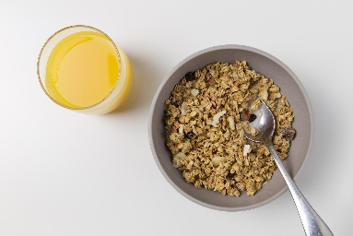

Breakfast Club

The Breakfast Club is an excellent morning service and suits many of our working parents and also those parents who find it easier for their child to eat breakfast at school. We are delighted to be able to continue to offer our Breakfast Club each morning from 8.15am. The cost remains the same at £1 per day.
To keep in line with COVID-19 restrictions and provide maximum safety for our children the Breakfast Club will be run within the protective bubbles this year. Children attending will enter the main building by the side door, have their temperature checked and then proceed to their individual classrooms where breakfast will be served.
There will be a selection of toast, pancakes, cereals and juice available with the last serving at 8.45am. Due to the service being provided in the classrooms it will not be possible to serve after 8.45am. Children arriving between 8.45am and 9am may use the service for supervision and the cost remains £1.
We ask that parents do not proceed beyond the pedestrian gate due to COVID-19 restrictions. Children will not be permitted into the building prior to 8.15am as staff will be arriving, sanitising and setting up for service.
Breakfast Club begins on Tuesday 1st of September and we look forward to welcoming our boys and girls from 8.15am.

