April 2017 Newsletter

Diary Dates

- Easter Feis and Draw
Tuesday 11th April
- Easter Holidays
Wednesday 12th April (school closes @ lunch time)
- Term 3 begins
Monday 24th April
- P1 Letters to Parents re: School Places Allocation Saturday 29th April
- First Holy Communion – Saturday 6th May @11am in St Theresa’s Church, Sion Mills.

Milk Money
£2.60 for the month of April, payable now.

Tin Whistle
£3.00 for the month of April, payable now.

Easter Draw
Tickets are now on sale for our Easter Draw which will take place at our ‘Feis’ on Tuesday 11th April. All proceeds from the draw will go towards school funds. £1 per ticket. A huge Thank You to all of those parents who have donated a prize for our draw as well as to the local businesses that have provided prizes too…
- The Sperrin Restaurant, Omagh
- O’Neills, Strabane
- Devine’s Mace, Victoria Bridge

Easter Feis
Our Easter Feis will take place in the Hall on Tuesday 11th April from 9.30am. All parents, family and friends are welcome to join us as we celebrate our pupils’ talents in music, song, drama and prose amongst other things.

Questionnaires
Hopefully by now all of you will have received a questionnaire as part of our preparations for our School Development Plan for 2017-2020. Your responses (anonymous) are extremely important to us and will help our Staff and Governors decide the way forward for St Eugene’s PS. This is your opportunity to have your say. Please return these to the office or your child’s teacher in the envelope provided.

Each child who returns a questionnaire on behalf of their family will be entered into a draw for an Easter Themed prize.
Closing date for questionnaires to be returned for the draw is Tuesday 11th April 2017.
Transfer to Post Primary
Each year, P7 pupils who wish to attend Grammar Schools in their local area choose to sit Transfer Entrance Exams (known commonly as GL and AQE Assessment). Other pupils opt not to sit exams and apply to non-Grammar schools in the local area. In the past, preparation of pupils for ‘The Transfer’ has been frowned upon by the Department of Education; however this is no longer the case and schools are free to prepare pupils. To this end, we have included a question regarding these exams in your Parent Questionnaire. Please read this question carefully and respond accordingly.

Morning Drop Off (Breakfast Club)
We are pleased to announce that a Breakfast Club will run for a trial period of 4 weeks beginning on Monday 24th of April. The Breakfast Club will be open from 8.15am and children will be supervised here until 9am. To avail of the Breakfast Club there will be a cost of £1 per child, per day. Further details will be provided in a letter that will be issued before the Easter break. Please complete and return the expression of interest form on the back of the newsletter to help us prepare.

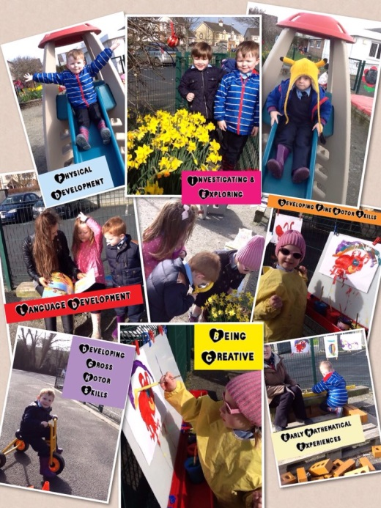
Induction Programme
Miss Gormley will deliver an induction programme for parents of children joining our Pre-School group and Primary One in the next academic year (2017-2018). The induction programme will take place over three sessions in May and Parents and Children involved in this will be notified when the P1 places have been formally allocated.

‘Rub A Dub Hub’ for Preschool Child
Rub-a-Dub Hub is a free online resource with tools, tips and fun activities to enable parents and carers to support preschool children, with confidence, during the early stages of reading and dealing with emotions. Created by Libraries NI, with input from healthcare and literacy professionals, Rub-a-Dub Hub provides a foundation to help little ones grow and learn as they embark on the first chapter of their lifelong reading adventure. Although primarily for 0-4 year olds, this excellent resource is well worth investigating if you have a child in P1 or P2….
https://www.librariesni.org.uk/sites/RADH/Pages/default.asp
Value of the Month
Each month we will be concentrating with the children upon a value that we hope the children will show at school and at home. Values will be discussed in class and at Assembly. Each month the staff will identify a member of each class who has been particularly good at living out that value. This month’s focus: Patience

Prayer of the Month
Please keep note of the prayer for the month of April and say this at home with your child.
The Angel of the Lord declared onto Mary,
And she conceived of the Holy Spirit.
Hail Mary……..

Behold the handmaid of the Lord,
Be it done unto me according to your word.
Hail Mary…….

And the word was made flesh,
And dwelt among us.
Hail Mary……..

Pray for us, O Holy Mother of God,
That we may be made worthy of the promises of Christ

Let us pray,
Pour forth we beseech O Lord,
Your grace into our hearts,
That we to whom the incarnation
Of Christ your Son was made known
By the message of an angel,
May by his passion and cross
Be brought to glory of his resurrection.
Through the same Christ our Lord.
Amen

REPLY SLIP BREAKFAST CLUB OVERLEAF

Uniform
On our return to school after Easter, we will have entered our ‘Summer’ term (hopefully the weather will reflect this!) and therefore pupils can begin to wear our ‘Summer’ uniform should they wish. Girls may wear summer dresses and Boys can wear a pale blue polo shirt and plain navy shorts (not sports shorts). Jumpers are still required and we would also encourage the wearing of black footwear (Velcro for Reception/P1/P2).

Minecraft
Our P5-7 pupils have now had the 3rd of four sessions of Minecraft with Stem Aware. The children are working together and developing their Problem Solving and Maths skills whilst ‘building’ a ‘model’ of our entire school and grounds. The Virtual Reality version of St Eugene’s is almost entirely complete – well done to all of our ‘Miners’!

Lego Appeal
Do you have any unwanted Lego (or other blocks, bricks or construction toys in good condition) at home? If the answer is ‘Yes’ then please let us know as we would gladly accept any donations for use in our classrooms!

Twitter
We would love to see many more parents and friends follow us at @StEugene58. You can join at www.twitter.com and begin following our school (@StEugene58). New photos added daily!

Outside of School:
Gaelic Start continues on Friday evenings at St Eugene’s GAA Newtownstewart. Qualified coaches will be on hand to offer training in the fundamental skills of Gaelic Football for all children from P1 upwards. P1-4 (6-7pm), P5&6 (7-8pm).

Athletics: This coaching is delivered by Mark Connolly who has worked closely with our school in the past and we strongly recommend it for a healthy mind and body:
- Melvin Sports Complex – Monday: 4- 5pm (Under 8’s) & 5-6pm (9 years +)
- Derg Valley – Wednesday: 4- 5pm (Under 8’s) & 5-6pm (9 years +)

-----------------------------------------------------------------------------------------------------------------
Breakfast Club
I would be interested in my child/children ________________________________________________
attending the Breakfast Club.
Every morning Monday - Friday
Some mornings
Signed __________________________________ Date ______________________________

