Accessing Fronter at Home

Fronter is a virtual learning environment where pupils can safely access information, both at home and in school, that has been created by their teacher.
Through Fronter, pupils can follow links to websites, powerpoints and interactive games. They can also watch videos, take quizzes and participate in discussions about topics with their teacher and peers. These discussions are closely monitored by their teacher. Using Fronter, pupils can also upload pieces of work to show their teacher and friends.
This week in school we will be celebrating World Book Day. Therefore a Fronter Course has been set up on World Book Day 2017 for the children in P3-7 to take part in.
Follow these instructions to access the course at home.
- Go to www.c2kschools.net
- When you see the My School login page, enter your school username and password and login.

- You will see your school homepage. Click the My Links button.
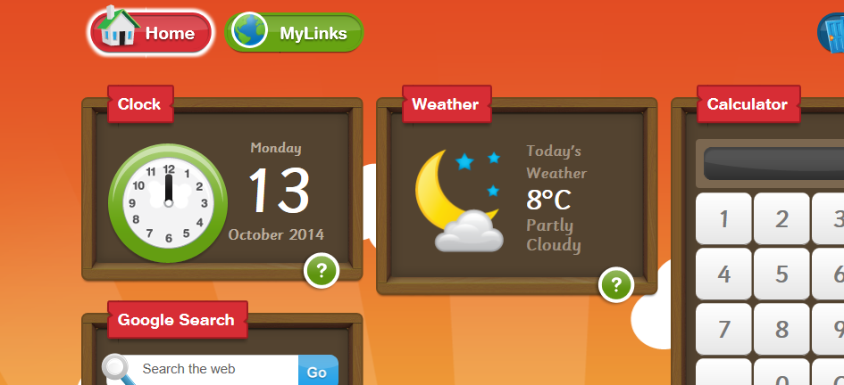

- Click on the Fronter button

- Click on ‘World Book Day 2017’ Course

- You will now enter ‘World Book Day 2017’ room. Click on the following button to enter Full Screen Mode.
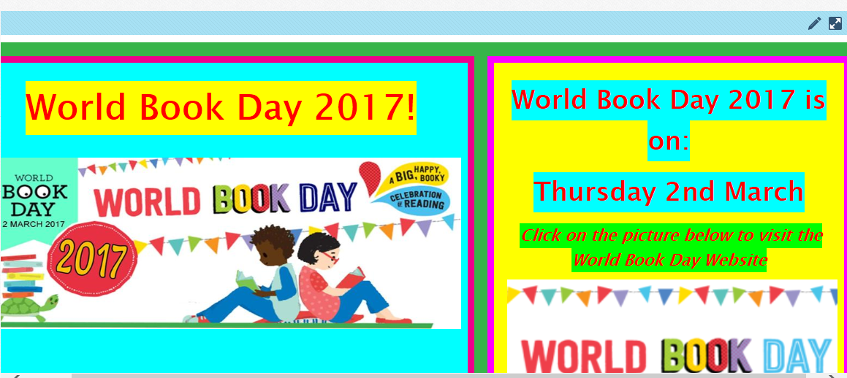

- You are now ready to explore ‘World Book Day 2017’ room!

Extreme Reading
- Ask your mum or dad to take a photograph of you reading in an unusual place, e.g. in the garden, on the stairs, in a shop, in the car etc.
- Save your photograph on your computer and give it an appropriate name e.g Mr Gallagher’s Extreme Reading Photo.
- Upload your photo to the World Book Day 2017 Fronter Course, using the following instructions:

- Under the Extreme Reading Section of the Course, click on Upload your Extreme Reading Photographs here

- Click on Upload File

- Click on Single File Upload

- Browse for the photograph that you have saved on your computer and click on it.

- Click Save

- Your Extreme Reading Photograph is now saved on Fronter for your teacher and classmates to see!

